ODGOJNO – OBRAZOVNO PODRUČJE:
ZADATAK: POGLEDAJTE SLIKE I ISPRIČAJTE ŠTO NA NJIMA VIDITE! POMOGNITE DANAS VAŠIM UKUĆANIMA U PRANJU VAŠEG AUTOMOBILA!

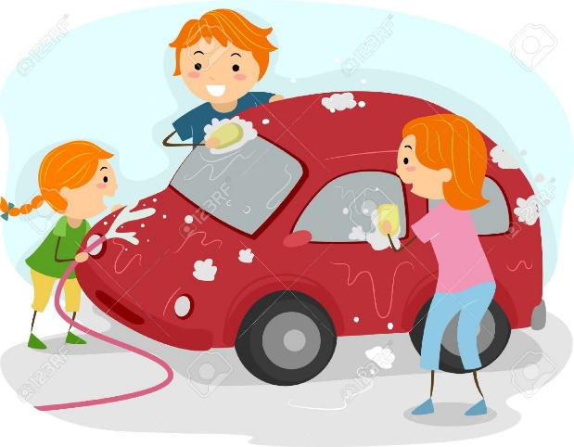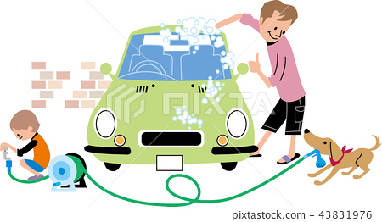

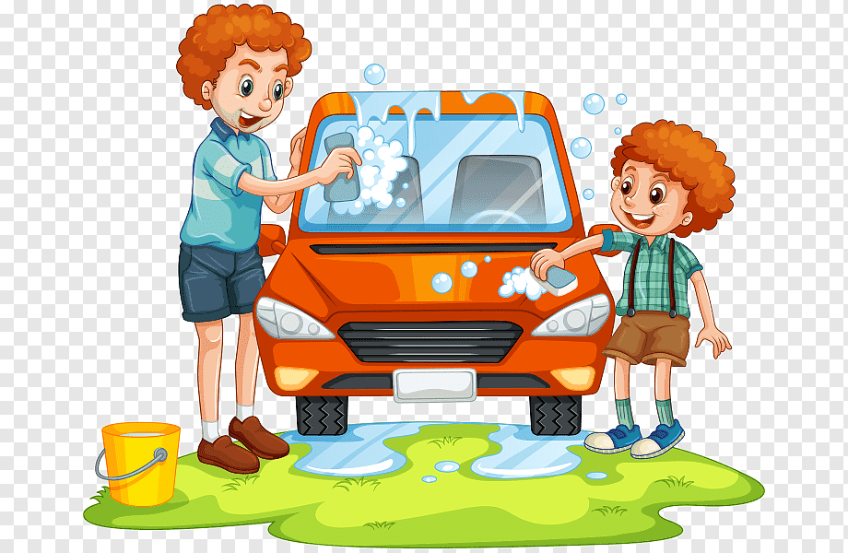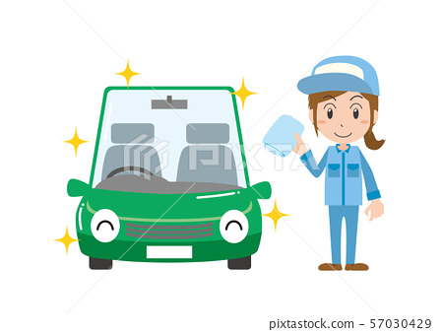

* Slike su uzete s internetskih stranica:
https://previews.123rf.com/images/lenm/lenm1204/lenm120400083/13340410-illustration-of-a-family-washing-their-car.jpg
https://en.pimg.jp/043/831/976/1/43831976.jpg
https://w7.pngwing.com/pngs/531/715/png-transparent-car-wash-cleaning-washing-car-child-toddler-car.png
https://en.pimg.jp/057/030/429/1/57030429.jpg

