PETAK, 11.6.2021. HRVATSKI JEZIK-MT,SB

**NAPIŠI ŠTO JE SPOJENO:**

bik3dar3

pas4

**______________________________**

gol2

**______________________________**

mačlav

luk4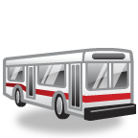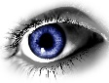ježfenborkap2koš5duhkit2puž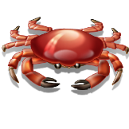noj

**______________________________**

**______________________________**

**______________________________**

**______________________________**

**______________________________**

**______________________________**

**______________________________**

**______________________________**