**SORTIRANJE/RECIKLIRANJE – PAPIR**

[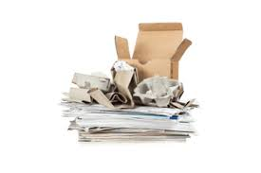](https://www.google.hr/imgres?imgurl=https://rcco.hr/wp-content/uploads/2016/12/papir.jpg&imgrefurl=https://rcco.hr/papir/&tbnid=PJdIEJ-NbY-HhM&vet=10CAMQxiAoAGoXChMImLPzvN-c6QIVAAAAAB0AAAAAEAY..i&docid=VeMAzUbv70r9iM&w=600&h=400&itg=1&q=recikliranje%20papira&ved=0CAMQxiAoAGoXChMImLPzvN-c6QIVAAAAAB0AAAAAEAY)[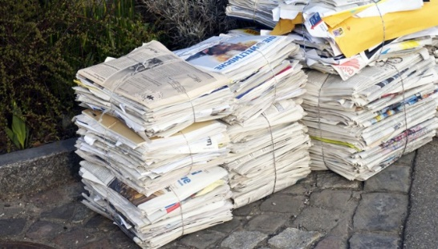](https://www.google.hr/url?sa=i&url=http://www.h-alter.org/vijesti/tajna-veza-bicikla-i-papira&psig=AOvVaw15JZKmgQj8hc2scMM7g7L_&ust=1588768877895000&source=images&cd=vfe&ved=0CAIQjRxqFwoTCJiz87zfnOkCFQAAAAAdAAAAABAJ)

**SAKUPLJAMO I BACAMO U**



**PLAVI KONTEJNER ZA PAPIR,**

**IZ NJIH SE SKUPLJA KAMIONIMA I VOZI U**



**TVORNICE GDJE SE PONOVNO PRERAĐUJE**



**KROZ PROCES PROIZVODNJE/ RECIKLIRANJA U**

[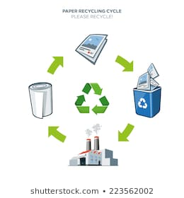](https://www.google.hr/url?sa=i&url=https://www.shutterstock.com/image-vector/life-cycle-paper-recycling-simplified-scheme-223562002&psig=AOvVaw15JZKmgQj8hc2scMM7g7L_&ust=1588768877895000&source=images&cd=vfe&ved=0CAIQjRxqFwoTCJiz87zfnOkCFQAAAAAdAAAAABBg)

**NOVE PROIZVODE: NOVINE, BILJEŽNICE, TOALET PAPIR, KARTON.**