**POVEŽI SLIKU/PREDMET I RIJEČ**

[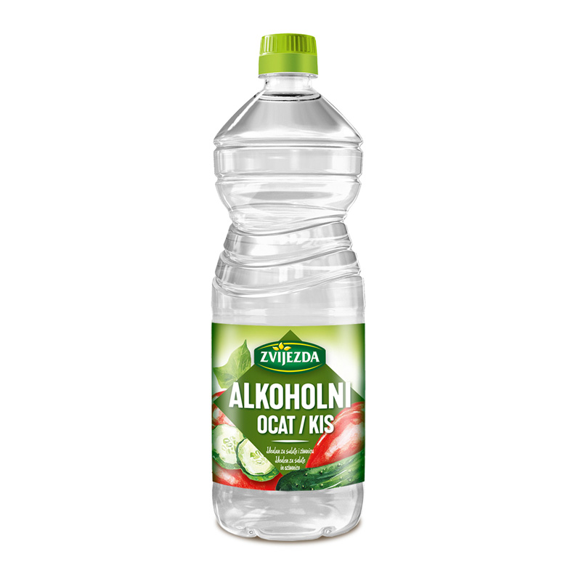](https://www.google.hr/url?sa=i&url=https%3A%2F%2Fwww.zvijezda.hr%2Fproduct%2Falkoholni-ocat%2F&psig=AOvVaw3hfUrIn2X22_2aq_bxSpZ3&ust=1620918508818000&source=images&cd=vfe&ved=0CAIQjRxqFwoTCLDv7pG2xPACFQAAAAAdAAAAABAD)

[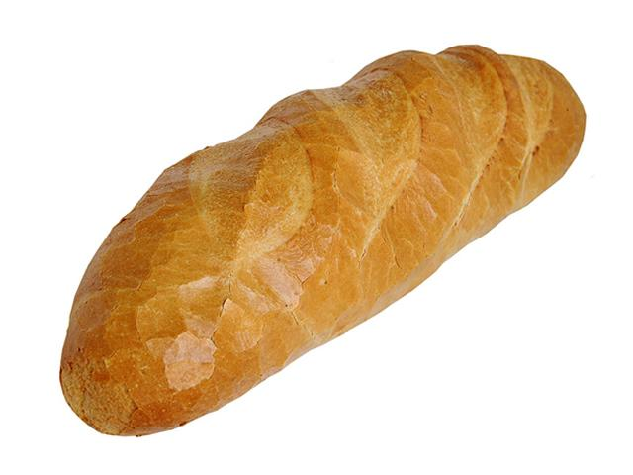](https://www.google.hr/url?sa=i&url=http%3A%2F%2Fwww.viro.hr%2Fhr%2Fprimjene%2Fpekarska-industrija%2F&psig=AOvVaw3fpLjuu03hmbh20tjMFgap&ust=1620918561744000&source=images&cd=vfe&ved=0CAIQjRxqFwoTCJCgsKu2xPACFQAAAAAdAAAAABAD)

[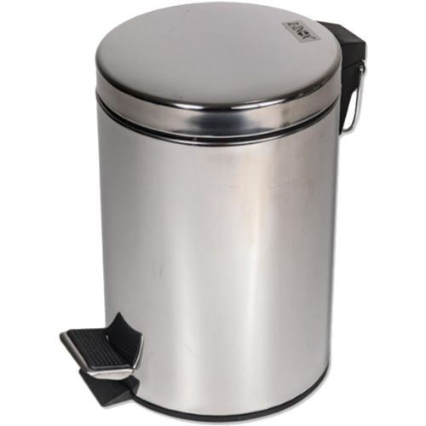](https://www.google.hr/url?sa=i&url=https%3A%2F%2Fbazzar.hr%2Fp%2FDE4DZRV-zilan-kos-za-smece-sa-pedalom-3-l-inox-zln6874&psig=AOvVaw04BbC9arQis1BaS3noB7Vg&ust=1620918625733000&source=images&cd=vfe&ved=0CAIQjRxqFwoTCNiXws22xPACFQAAAAAdAAAAABAD)

**OCAT**

**KRUH**

**KOŠ**