ČETVRTAK,15.4.2021. PRIRODA I DRUŠTVO- SVI UČENICI
ŽIVOT U SLANIM VODAMA-MORU I OCEANU
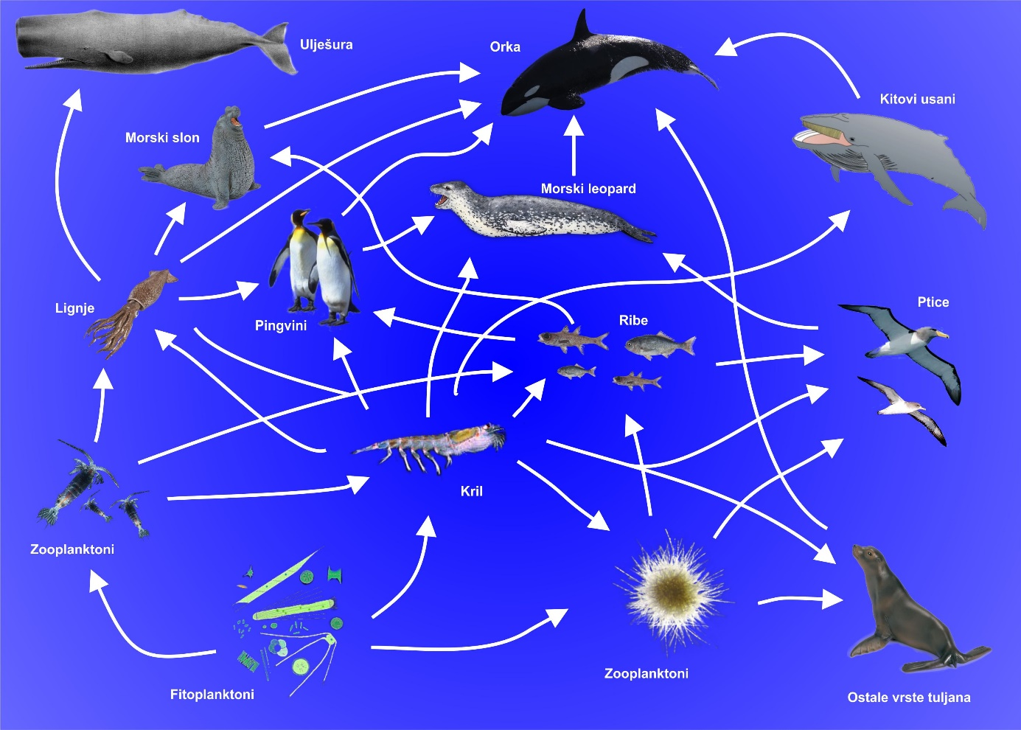
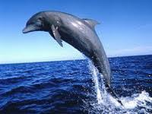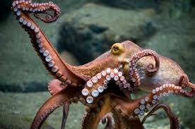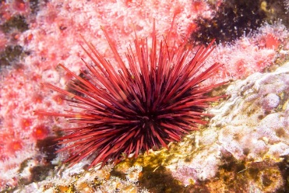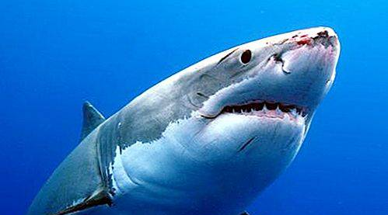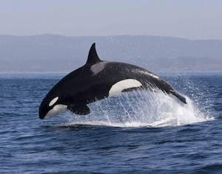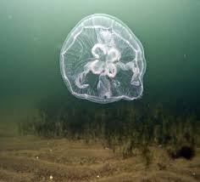
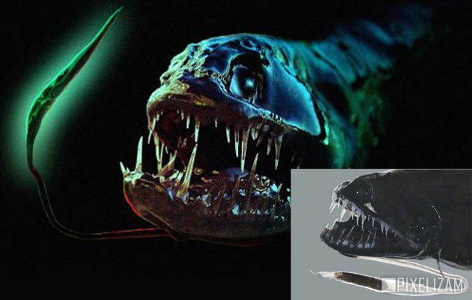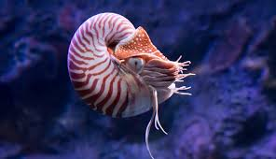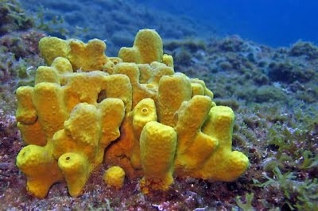

PREPOZNAJ, PROČITAJ, POKAŽI I NAUČI KOJE SVE ŽIVOTINJE ŽIVE UMORU I OCEANU. NAPIŠI IH: ________________________________________________________________________________

__________________________________________________________________________________

__________________________________________________________________________________

__________________________________________________________________________________

__________________________________________________________________________________

__________________________________________________________________________________

