**PROMETNA SREDSTVA NA CESTI**

**[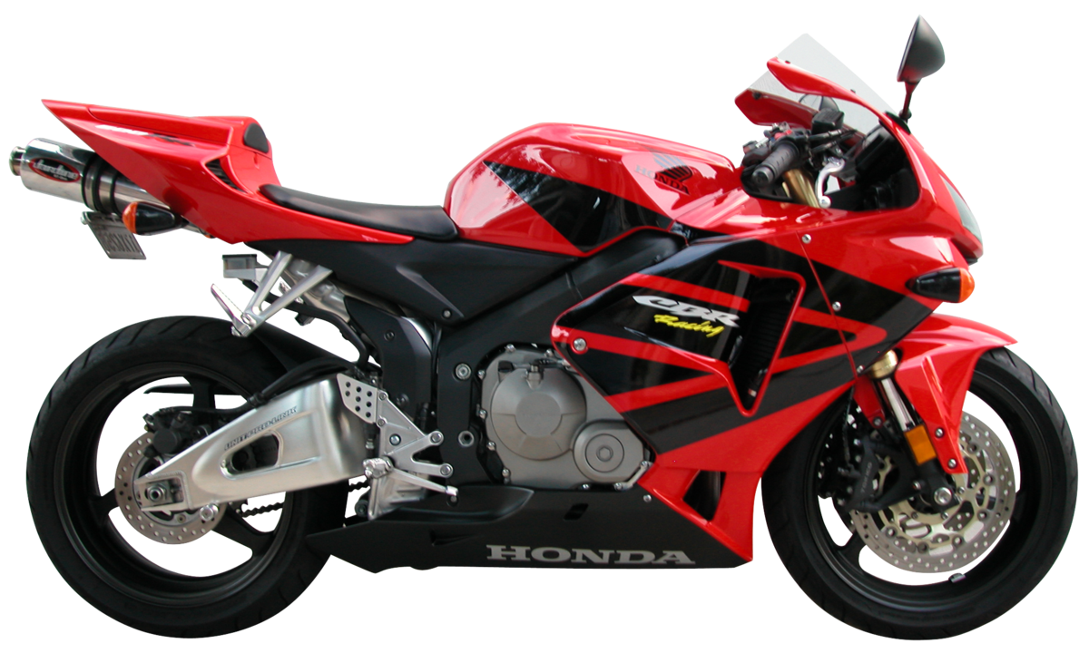](https://www.google.hr/url?sa=i&url=https://hr.wikipedia.org/wiki/Motocikl&psig=AOvVaw3aj5twuCtAtAILBx2-BPzY&ust=1618346425347000&source=images&cd=vfe&ved=0CAIQjRxqFwoTCKDJxbLI-e8CFQAAAAAdAAAAABAD)**

**MOTOCIKL**

**[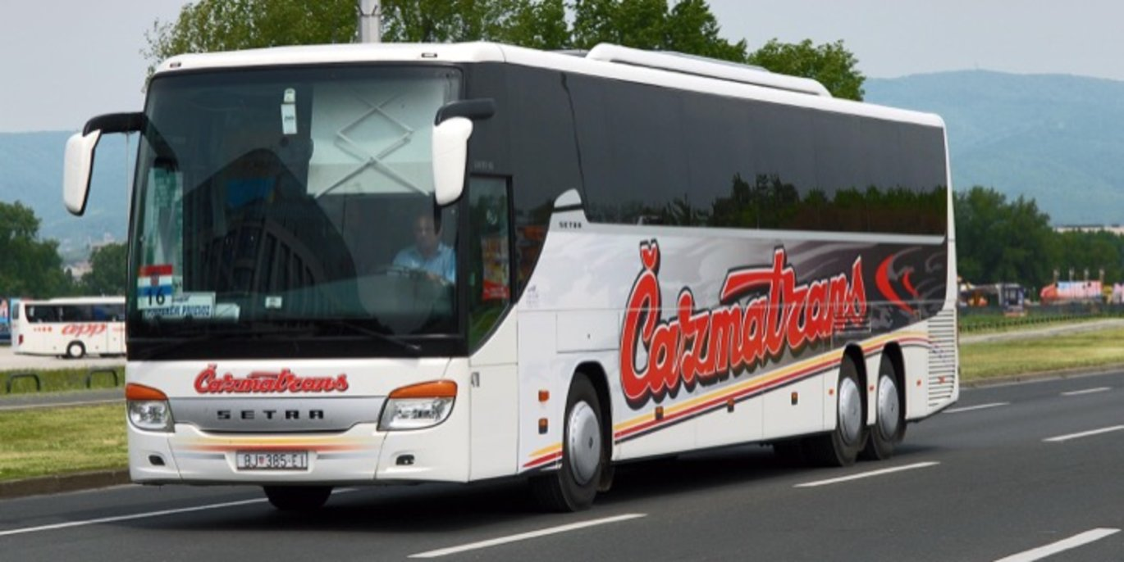](https://www.google.hr/url?sa=i&url=https://cazmatrans.hr/hr/putnicka-agencija/najam-autobusa&psig=AOvVaw2LYHVyeghRhLpBxBZn3FJl&ust=1618346508885000&source=images&cd=vfe&ved=0CAIQjRxqFwoTCPDJxt3I-e8CFQAAAAAdAAAAABAe) AUTOBUS**

**[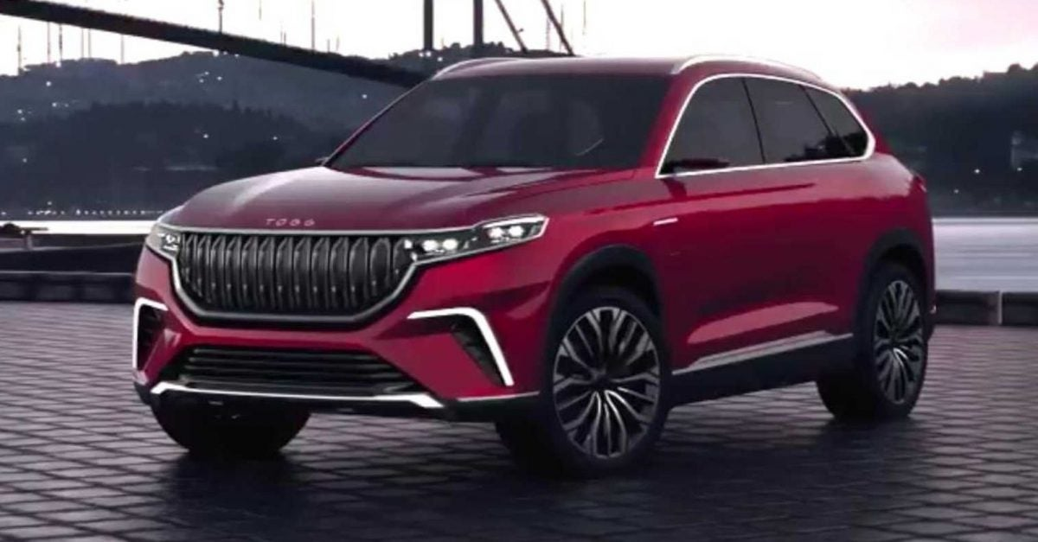](https://www.google.hr/url?sa=i&url=https://www.mobilegeeks.de/news/togg-erdogan-stellt-das-erste-tuerkische-e-auto-vor/&psig=AOvVaw2tJ_EKd3T993e4bQa2ovur&ust=1585768782401000&source=images&cd=vfe&ved=0CAIQjRxqFwoTCNiDtfG1xegCFQAAAAAdAAAAABAJ)**

**AUTOMOBIL**

**[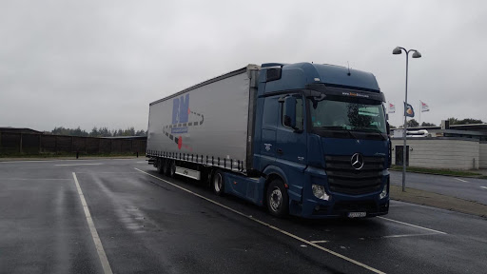](https://www.google.hr/url?sa=i&url=http://lme-ltrans.hr/&psig=AOvVaw2Qom-mqs72f2EnqtjkPgP3&ust=1585768873774000&source=images&cd=vfe&ved=0CAIQjRxqFwoTCJjl9bm2xegCFQAAAAAdAAAAABAD)**

**KAMION**

**[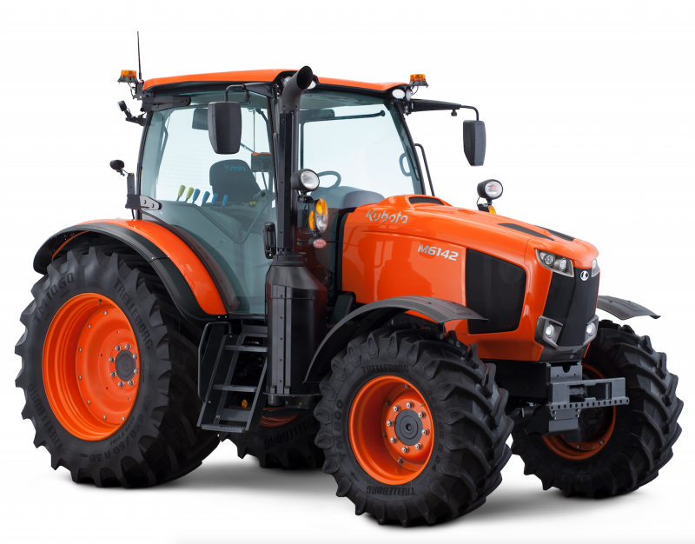](https://www.google.hr/url?sa=i&url=https%3A%2F%2Fgospodarski.hr%2Fcasopis%2Fizdanja-2020-casopis%2Fbroj-7-od-15-04-2020-izdanja-2020-casopis%2Fkubota-lansira-novu-seriju-traktora-m6002%2F&psig=AOvVaw1Tnyf8iTxMN2iXm6uDqeGp&ust=1618347202681000&source=images&cd=vfe&ved=0CAIQjRxqFwoTCLD83aTL-e8CFQAAAAAdAAAAABAD)**

**TRAKTOR**