SRIJEDA, 31.3.2021. HRVATSKI JEZIK-LK
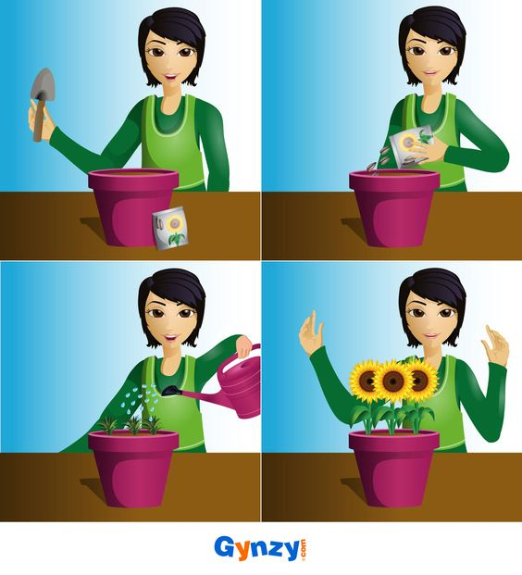
PROMATRAJ PRIČU U SLIKAMA. OPIŠI SVAKU SLIKU PO REDOSLIJEDU. OSMISLI NASLOV I NAPIŠI GA. ZA SVAKU SLIKU NAPIŠI PO JEDNU REČENICU.

NASLOV: _________________________________________________

1._________________________________________________________________________________

__________________________________________________________________________________

2._________________________________________________________________________________

__________________________________________________________________________________

3._________________________________________________________________________________

__________________________________________________________________________________

4._________________________________________________________________________________

__________________________________________________________________________________

