SAT
NAPIŠI KOLIKO JE SATI!
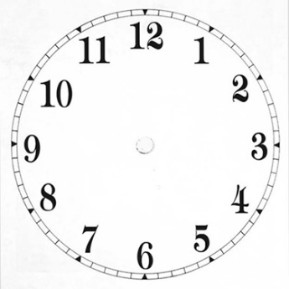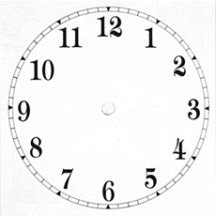

-------------------------- --------------------------- -------------------------- -----------------------------

----------------------------- ------------------------------- ---------------------------------- --------------------------------

NACRTAJ KAZALJKE!
1 SAT 3 SATA 6 SATI
5 SATI 10 SATI 12 SATI

