**SREDSTVA ZA OSOBNU HIGIJENU**

**[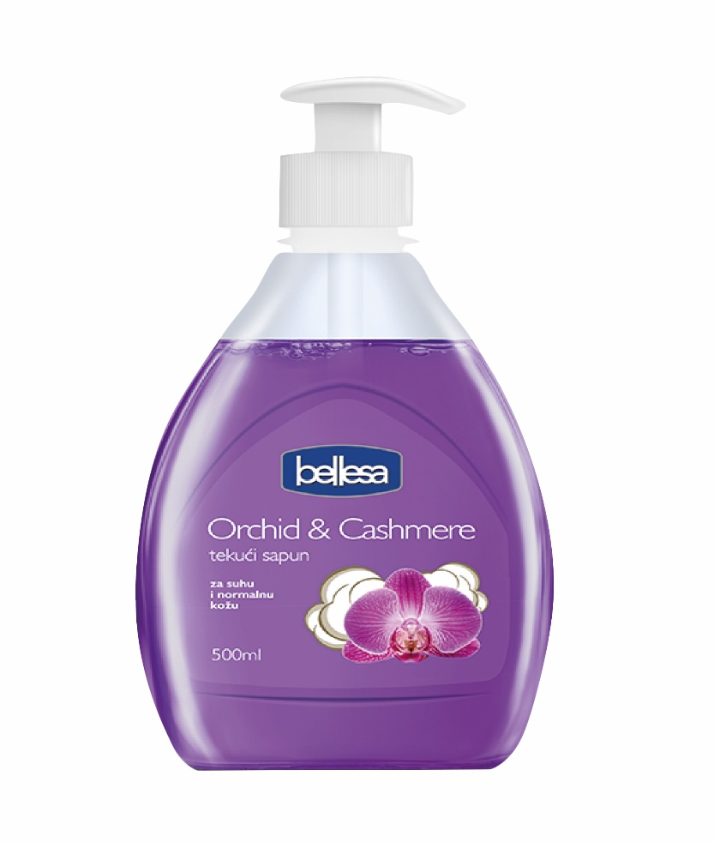](https://www.google.hr/url?sa=i&url=https%3A%2F%2Fntl.hr%2Fproizvod%2Ftekuci-sapun-orchid-cashmere-500-ml-bellesa-946&psig=AOvVaw0hfSE3Jcc9WjjsE1-z4ym3&ust=1590817990977000&source=images&cd=vfe&ved=0CAIQjRxqFwoTCKC28fyw2OkCFQAAAAAdAAAAABAI)SAPUN**

**[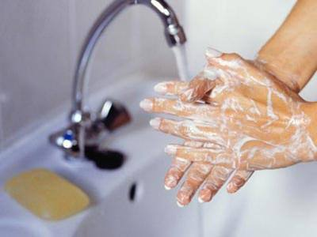](https://www.google.hr/url?sa=i&url=http%3A%2F%2Fwww.info-ks.net%2Fclanak.php%3Fid%3D25867&psig=AOvVaw0hfSE3Jcc9WjjsE1-z4ym3&ust=1590817990977000&source=images&cd=vfe&ved=0CAIQjRxqFwoTCKC28fyw2OkCFQAAAAAdAAAAABAT)**

**PRANJE RUKU**

**[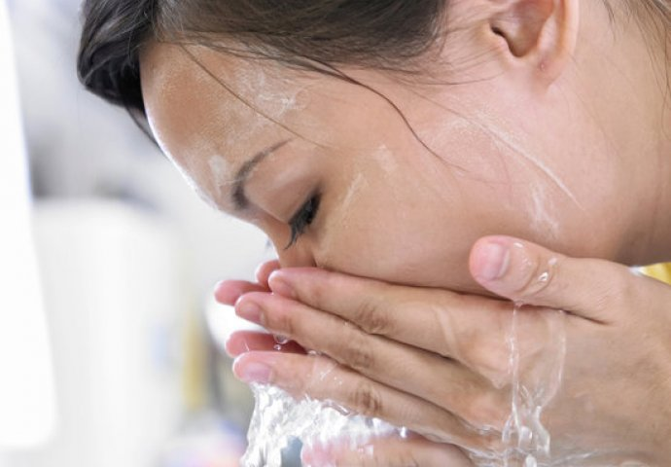](https://www.google.hr/url?sa=i&url=https%3A%2F%2Fm.novi.ba%2Fclanak%2F222673%2Fprednosti-umivanja-lica-hladnom-vodom-saznajte-kako-utice-na-vasu-kozu&psig=AOvVaw0UzbH737eCr2ns6Bd-Cs7B&ust=1590818357380000&source=images&cd=vfe&ved=0CAIQjRxqFwoTCIi2jbey2OkCFQAAAAAdAAAAABAD)**

**UMIVANJE LICA**

**[](https://www.google.hr/url?sa=i&url=https%3A%2F%2Fwww.apnea-arbanas.hr%2Fsport-microfiber-ru%25C4%258Dnik&psig=AOvVaw3_e-g8hOdnOVuBmMBIB7we&ust=1590818167797000&source=images&cd=vfe&ved=0CAIQjRxqFwoTCLiIqN6x2OkCFQAAAAAdAAAAABAP)RUČNIK**

**[](https://www.google.hr/url?sa=i&url=https%3A%2F%2Fm.vecernji.hr%2Flifestyle%2Fstrucnjaci-upozoravaju-nemojte-brisati-lice-nakon-umivanja-rucnicima-1248887&psig=AOvVaw0ueuxE4bDNuc7hBQ7qqimf&ust=1590819751979000&source=images&cd=vfe&ved=0CAIQjRxqFwoTCNj0uMy32OkCFQAAAAAdAAAAABAL)**

**BRISANJE**

**[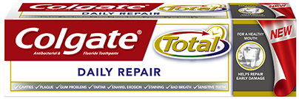](https://www.google.hr/url?sa=i&url=https%3A%2F%2Fwww.colgate.hr%2Fapp%2FColgateTotal%2FHR%2FProducts%2FColgate-Total-Daily-Repair-Toothpaste%2FHome.cwsp&psig=AOvVaw0C-OSLpkubjgip1TniDMpk&ust=1590818454789000&source=images&cd=vfe&ved=0CAIQjRxqFwoTCOi5quGy2OkCFQAAAAAdAAAAABAD)**

**PASTA ZA ZUBE**

**[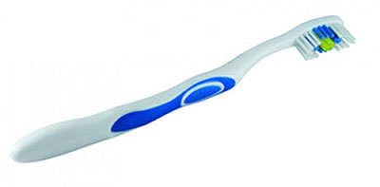](https://www.google.hr/url?sa=i&url=https%3A%2F%2Fwww.svezakucu.rs%2Fwww%2Flargerimage2.php%3Fid%3D69691%26opnpc%3Dpics%2Fitems%2Fportal%2Fbig%2F69691.jpg&psig=AOvVaw1tK4uRim1aXyxHuvSqBhd_&ust=1590818548924000&source=images&cd=vfe&ved=0CAIQjRxqFwoTCPCfoYez2OkCFQAAAAAdAAAAABAD)**

**ČETKICA ZA ZUBE**

**[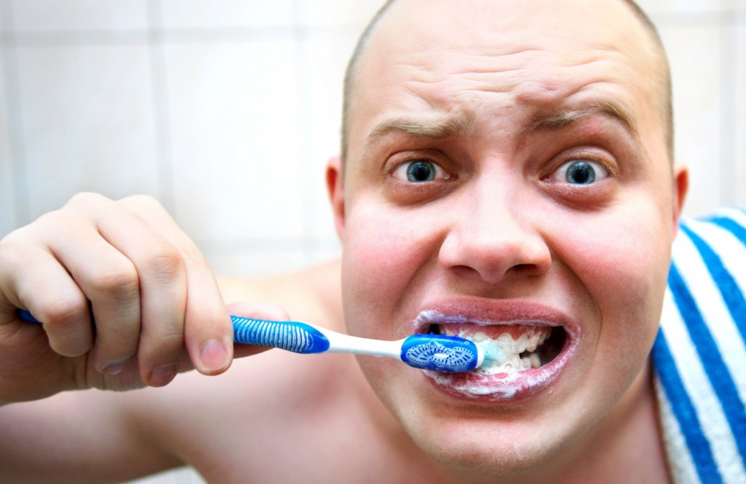](https://www.google.hr/url?sa=i&url=https%3A%2F%2Fpoliklinika-galekovic.hr%2Fblog%2Fpravilna-higijena-zubi-24%2F&psig=AOvVaw35PPvqaN5Fd2jilitn-_Ay&ust=1590818606209000&source=images&cd=vfe&ved=0CAIQjRxqFwoTCLDF56qz2OkCFQAAAAAdAAAAABAD)**

**PRANJE ZUBI**

**[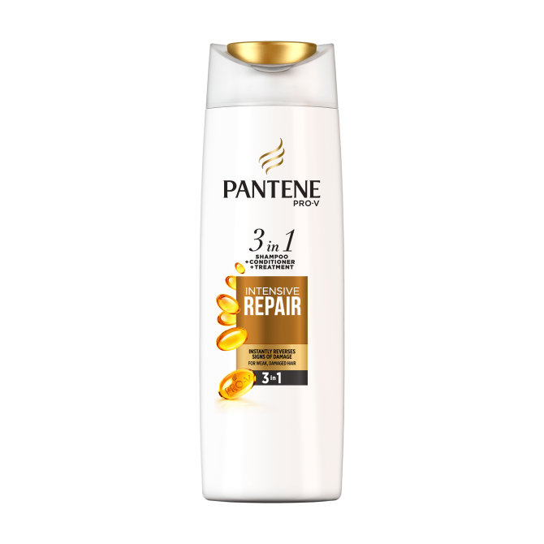](https://www.google.hr/url?sa=i&url=https%3A%2F%2Fsenzacionalno.hr%2Fpantene-sampon-za-kosu-3u1-repairprotect-360-ml-proizvod-590%2F&psig=AOvVaw2Q1DH9dyekqZePDEW8CnDg&ust=1590818704032000&source=images&cd=vfe&ved=0CAIQjRxqFwoTCNjV8taz2OkCFQAAAAAdAAAAABAD)ŠAMPON**

**[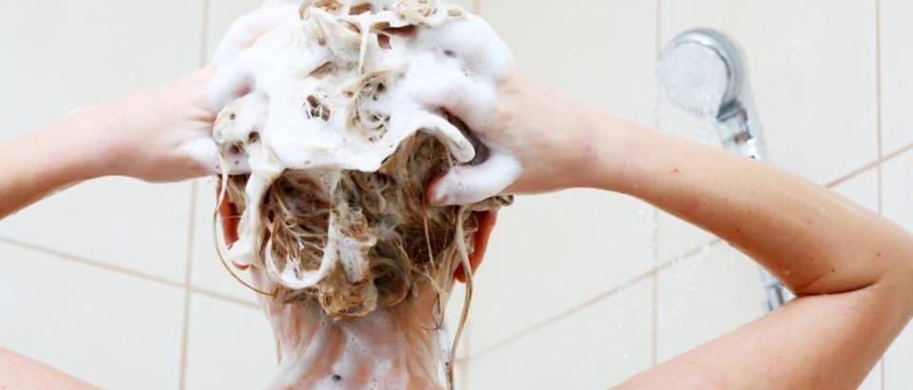](https://www.google.hr/url?sa=i&url=https%3A%2F%2Ftuzlanski.ba%2Flifestyle%2Fujutro-ili-uvece-tip-kose-odredjuje-vrijeme-pranja%2F&psig=AOvVaw0qTA8U3-Hhp16hGt8xr9mT&ust=1590818839806000&source=images&cd=vfe&ved=0CAIQjRxqFwoTCMDXtJW02OkCFQAAAAAdAAAAABAD)**

**PRANJE KOSE**

**[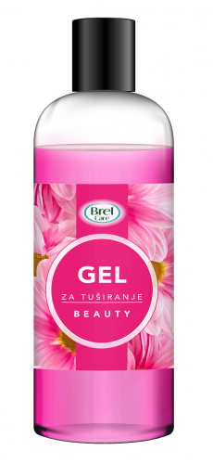](https://www.google.hr/url?sa=i&url=https%3A%2F%2Fwww.ultragros.hr%2Fproizvod%2Fljepota-i-njega%2Fbrel-care-gel-za-tusiranje-beauty-300ml-772&psig=AOvVaw11PBipcGhauPwIsdhjoiNK&ust=1590818915328000&source=images&cd=vfe&ved=0CAIQjRxqFwoTCMjDkcO02OkCFQAAAAAdAAAAABAD)GEL ZA TUŠIRANJE**

**[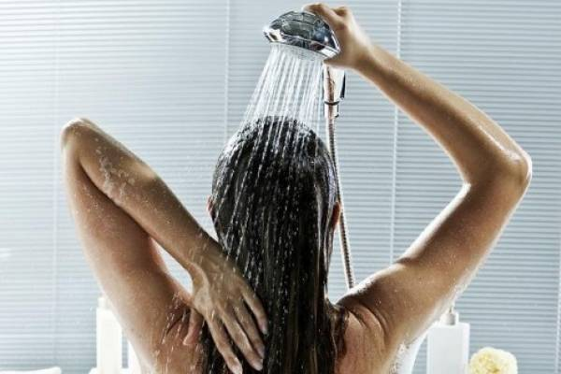](https://www.google.hr/url?sa=i&url=https%3A%2F%2Fpleter-portal.hr%2Findex.php%3Fid%3D27521&psig=AOvVaw3Yu5YppsNjcZjknW8ytm4U&ust=1590819015712000&source=images&cd=vfe&ved=0CAIQjRxqFwoTCNiJ5-202OkCFQAAAAAdAAAAABAE)**

**TUŠIRANJE**

**[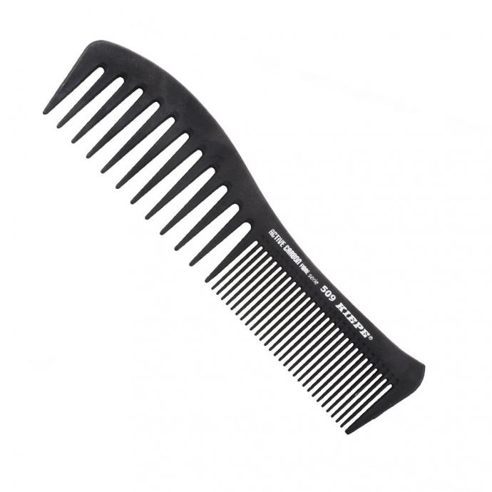](https://www.google.hr/url?sa=i&url=https%3A%2F%2Fwww.njuskalo.hr%2Fsolariji-saloni%2Fcesalj-kosu-antistaticki-kiepe-active-carbon-509-crni-oglas-26236806&psig=AOvVaw1EvbBuS88EIj1ZYW80PmZq&ust=1590819406291000&source=images&cd=vfe&ved=0CAIQjRxqFwoTCPDo6qO22OkCFQAAAAAdAAAAABAD)ČEŠALJ**

**[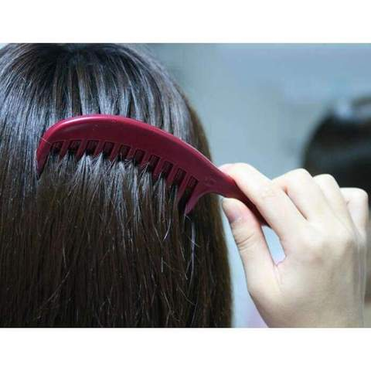](https://www.google.hr/url?sa=i&url=https%3A%2F%2Fhr.planet-gates.com%2Fproducts%2Fquality-21cm-detangle-brush-tooth-comb-hair-care-comb-as-hair-beauty-styling-tool-in-salon-accept-drop-ship&psig=AOvVaw0F4uW7o6CZtg3qA9Ewe4VQ&ust=1590819503242000&source=images&cd=vfe&ved=0CAIQjRxqFwoTCJimwNy22OkCFQAAAAAdAAAAABAD)**

**ČEŠLJANJE KOSE**

**[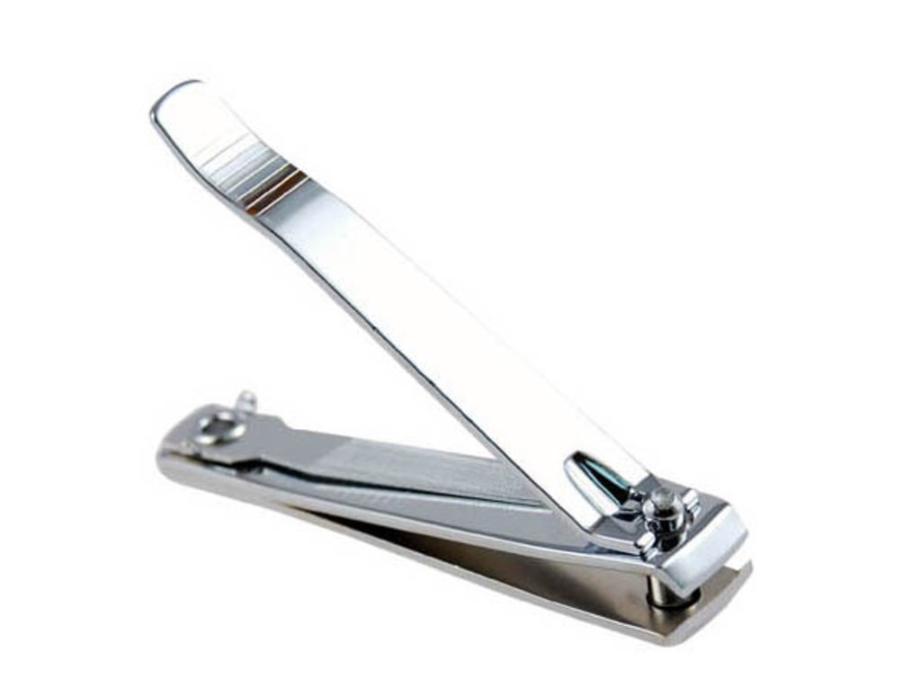](https://www.google.hr/url?sa=i&url=https%3A%2F%2Fwww.jeftinije.hr%2FProizvod%2F9799381%2Fljepota-i-zdravlje%2Faparati-za-zdravlje%2Fostali-aparati-za-zdravlje%2Fgrickalica-za-nokte&psig=AOvVaw2wgd5vt_YhPVpXhQXq5SYI&ust=1590819601778000&source=images&cd=vfe&ved=0CAIQjRxqFwoTCIjmgf222OkCFQAAAAAdAAAAABAD)**

**GRICKALICA ZA NOKTE**

**[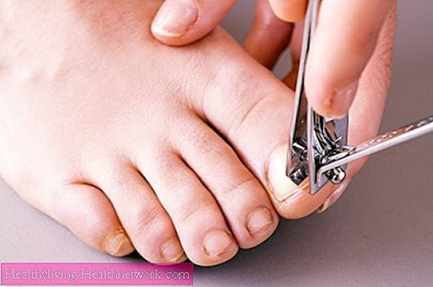](https://www.google.hr/url?sa=i&url=http%3A%2F%2Fostraluka.com%2Findex%2Fzivot%2Fsavjeti%2Fitem%2F31646-nau%25C4%258Dite-pravilno-rezati-nokte-na-nogama.html&psig=AOvVaw2Bj1C0hmuRcYibASyBZxda&ust=1590819660247000&source=images&cd=vfe&ved=0CAIQjRxqFwoTCNjDgp632OkCFQAAAAAdAAAAABAD)**

**REZANJE NOKTIJU**