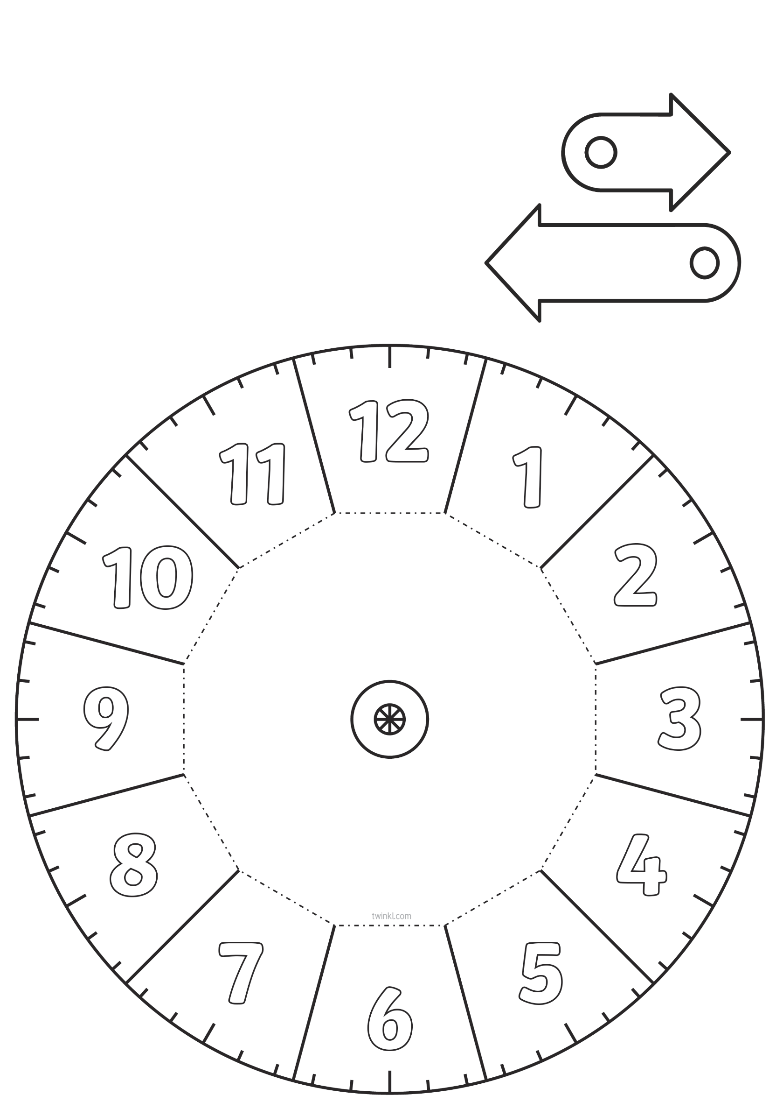

**URA ILI SAT**

1. Cut around the edge of both clock faces and cut the solid lines on the first clock to split the clock into 12 sections.
2. Fold the dotted lines upwards.
3. Glue the reverse of the central square from page 1 onto the middle of page 2, ensuring the clock sections match.
4. Punch a hole in the clock hands and then fasten them to the middle of the clock using a split pin.

