**KARAKTERISTIKE**

**ZIME**

**[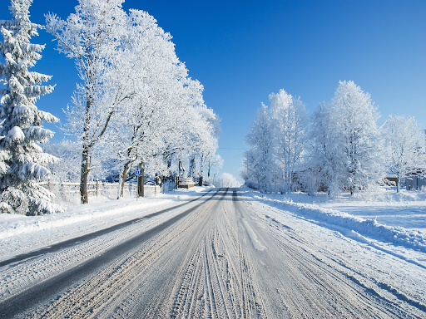](https://www.google.hr/url?sa=i&url=http://bih-x.info/danas-je-prvi-dan-zime/&psig=AOvVaw1nEFxX31UimT723lQk94JZ&ust=1606857774254000&source=images&cd=vfe&ved=0CAIQjRxqFwoTCNCuifmZq-0CFQAAAAAdAAAAABAE)**

**PADA SNIJEG**

**[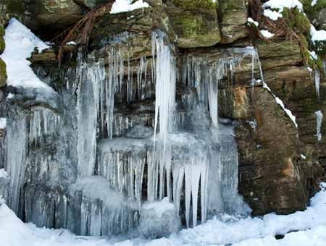](https://www.google.hr/url?sa=i&url=http://www.onegeology.org/extra/kids/croatian/earthprocesses/glacialIce.html&psig=AOvVaw2TW3n4bIh7ni2Ay38DXupa&ust=1606857971558000&source=images&cd=vfe&ved=0CAIQjRxqFwoTCODAgNaaq-0CFQAAAAAdAAAAABAE)**

**VODA SE ZALEDI**

**[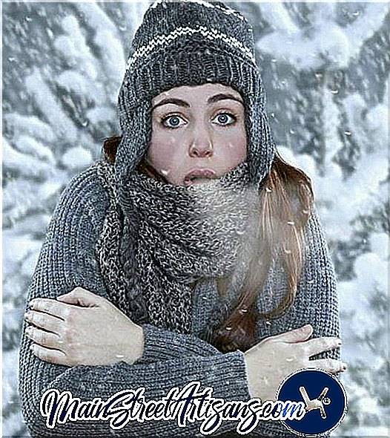](https://www.google.hr/url?sa=i&url=https://hrv.mainstreetartisans.com/4338671-what-quotes-about-the-cold-do-you-know&psig=AOvVaw2iZIEUU2eAYr0sS7OUNcP4&ust=1606858084778000&source=images&cd=vfe&ved=0CAIQjRxqFwoTCLDb9Y-bq-0CFQAAAAAdAAAAABAK)**

**JAKO JE HLADNO**