BOŽIĆ
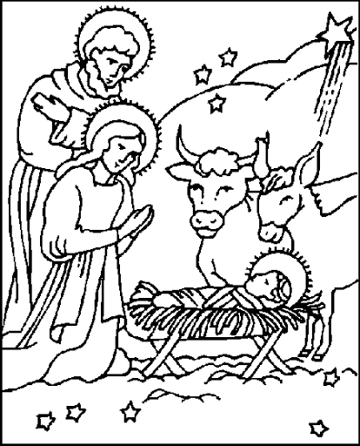

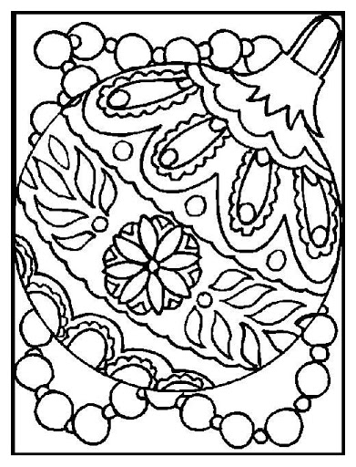

* Slika je uzeta sa internetskih stranica:
https://lh3.googleusercontent.com/proxy/SlxBafxyq8nPe3Q0N_UCyDDlsr_m1XF_-sM5T1uKhKGA-zZ_-lm_n9SBYhld-Jq_6AZ_zqzvgtdtMdcpx8R_UpGbmIJ_QKoXcXpGGdwr8CJM-nQ
https://lh3.googleusercontent.com/proxy/OKLjrFNVmio55Mj7TX5Bw-RXNS6hNVa1z0QCT8LRa-WL7CaJxMTpoHvEGIAdj5DATA6NG3i_8ZeL2GjlGfj0Abs0k_9H-CzuPcYxwWEgBKKk5g

