[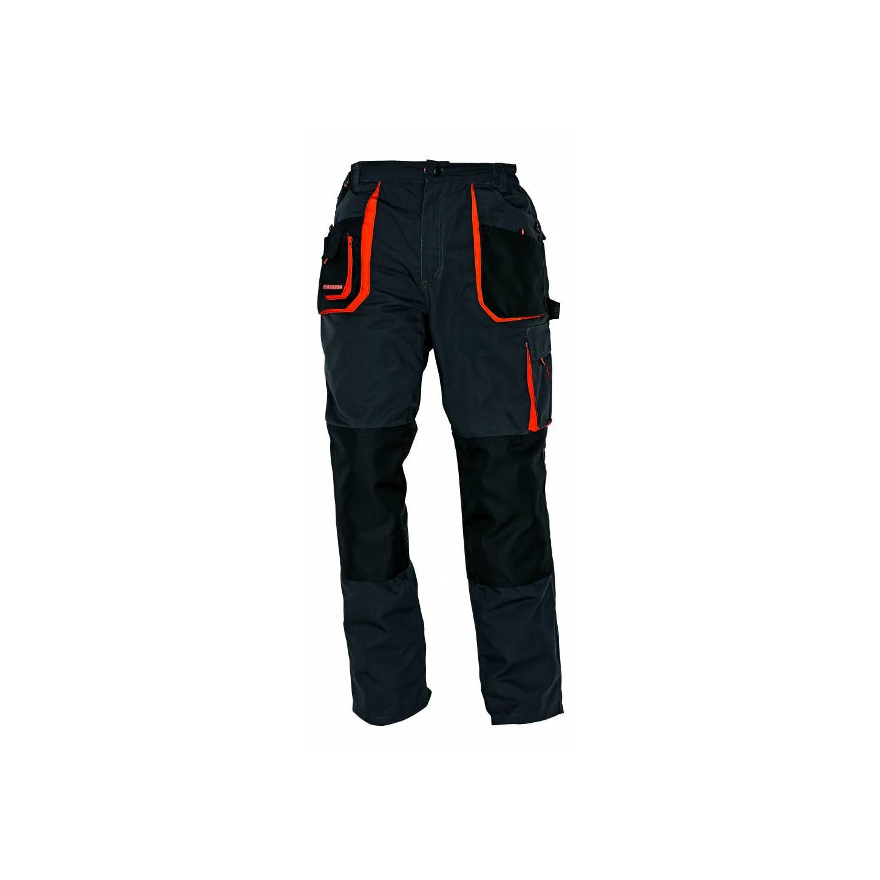](https://www.google.hr/url?sa=i&url=https%3A%2F%2Fwww.enormis.hr%2Fproizvod%2Fradne-hlace-cerva-emerton-2%2F&psig=AOvVaw3_7PDgNGXsaaLlCFZMOQ33&ust=1607698157011000&source=images&cd=vfe&ved=0CAIQjRxqFwoTCID3rsPUw-0CFQAAAAAdAAAAABAD)

**HLAČE**