**POVEŽI SLIKU/PREDMET I RIJEČ**

[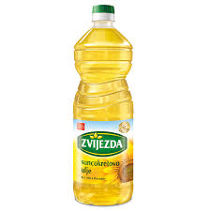](https://www.google.hr/url?sa=i&url=https%3A%2F%2Fwww.zvijezda.hr%2Fproduct%2Fsuncokretovo-ulje%2F&psig=AOvVaw3VtOQL-NLuv9fbd2-fKrWd&ust=1607607979312000&source=images&cd=vfe&ved=0CAIQjRxqFwoTCLC86cqEwe0CFQAAAAAdAAAAABAD)

[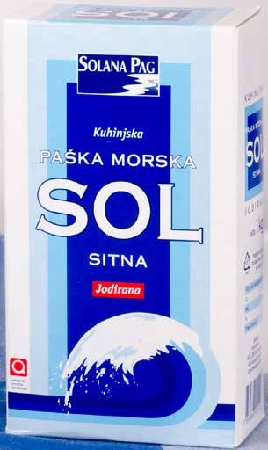](https://www.google.hr/url?sa=i&url=https%3A%2F%2Fpopusti.njuskalo.hr%2Fakcija%2Fsitna-morska-sol-solana-pag-1-kg-257453&psig=AOvVaw2RBRUxgu1S--0Nc0MBeASj&ust=1607608027778000&source=images&cd=vfe&ved=0CAIQjRxqFwoTCLjz4-aEwe0CFQAAAAAdAAAAABAD)

[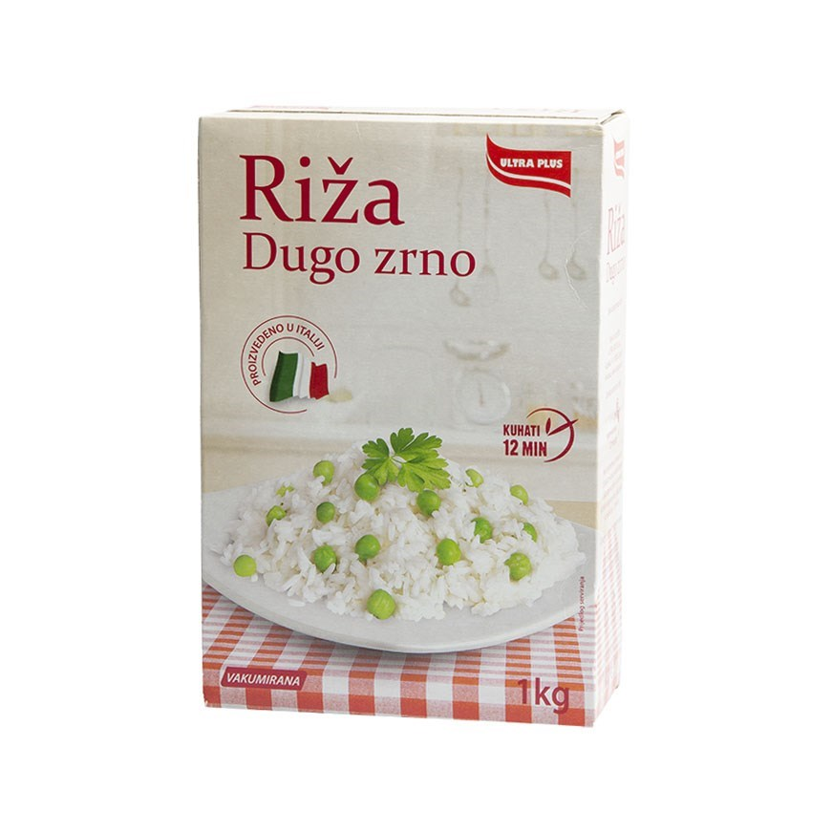](https://www.google.hr/url?sa=i&url=https%3A%2F%2Fwww.ppkbjelovar.com%2Fu-riza-dugo-zr1kg-30968.aspx&psig=AOvVaw29-vGl5tM97dX3nSIW1n7F&ust=1607608115312000&source=images&cd=vfe&ved=0CAIQjRxqFwoTCMD88o6Fwe0CFQAAAAAdAAAAABAE)

**ULJE**

**SOL**

**RIŽA**