UTORAK 8.12.2020. MATEMATIKA-AK,KH- NAUČI ČITATI BORJEVE:
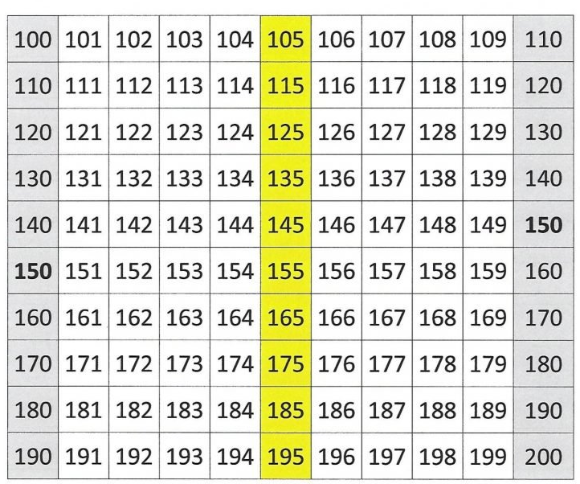

NAPIŠI BROJEVE OD 100 DO 200:
__________________________________________________________________________________

__________________________________________________________________________________

__________________________________________________________________________________

__________________________________________________________________________________

__________________________________________________________________________________

__________________________________________________________________________________

__________________________________________________________________________________

__________________________________________________________________________________

__________________________________________________________________________________

__________________________________________________________________________________

