**DONJE RUBLJE**

[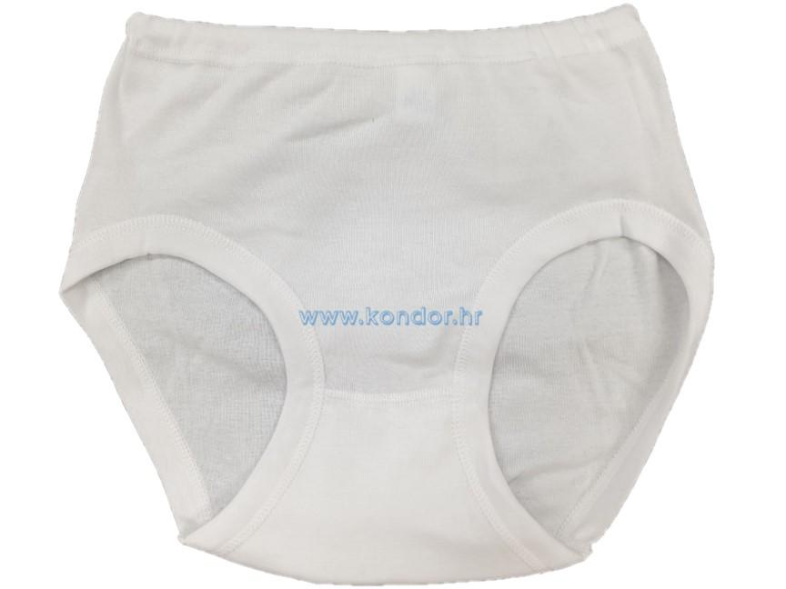](https://www.google.hr/url?sa=i&url=https%3A%2F%2Fkondor.hr%2Fproducts%2Fzenske-gace-devic&psig=AOvVaw3pSoaLFNHicj1DOLI4UTvz&ust=1606855851569000&source=images&cd=vfe&ved=0CAIQjRxqFwoTCNjW-9qSq-0CFQAAAAAdAAAAABAD)

**GAĆE**

**[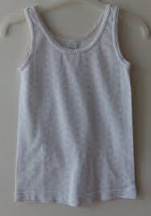](https://www.google.hr/url?sa=i&url=https%3A%2F%2Fmojekrpice.hr%2Fitems%2Fodjeca%2F9605051%2Fpotkosulja-devic-vel-6&psig=AOvVaw32qPzXkjvSl5NNo1tOx2XS&ust=1606855962014000&source=images&cd=vfe&ved=0CAIQjRxqFwoTCPi_35OTq-0CFQAAAAAdAAAAABAF)**

**POTKOŠULJA**

**[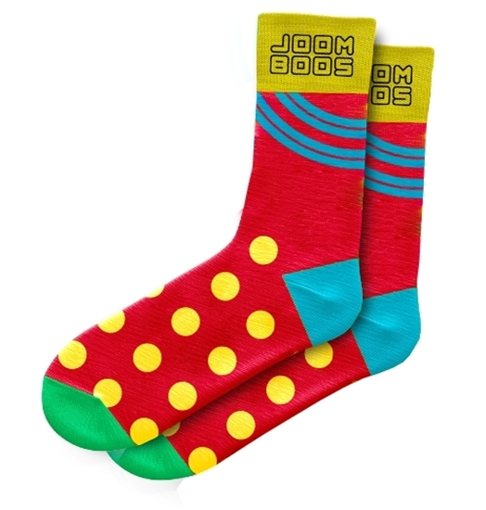](https://www.google.hr/url?sa=i&url=https%3A%2F%2Fwww.zutiklik.hr%2Fjoomboos-carape-44-46-crvene&psig=AOvVaw0s78tMZ2mbcW71RB7nNvAo&ust=1606856121488000&source=images&cd=vfe&ved=0CAIQjRxqFwoTCKjhx9uTq-0CFQAAAAAdAAAAABAD)**

**ČARAPE**