PONEDJELJAK 7.12.2020.MATEMATIKA-AK,KH
STOTICE DO 1000-NAUČI IH NAPAMET PO REDU:
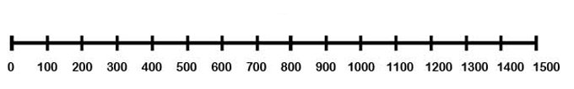
100- STO
200- DVJESTO
300- TRISTO
400- ČETRISTO
500- PETSTO
600- ŠESTO
700 - SEDAMSTO
800 - OSAMSTO
900- DEVETSTO
1000 – TISUĆU
NAPIŠI STOTICE PO REDU:
100,_______________________________________________________________________________

NAPIŠI DESETICE DO 200 PO REDU:
10,20,30,40,…_____________________________________________________________________

________________________________________________________________________________

