|  |  |  |  |  |
| --- | --- | --- | --- | --- |
| **MESO** | **RIBA** | **VOĆE** | **POVRĆE** | **ŽITARICE** |
|  |  |  | C:\Users\ZVJEZDANA\AppData\Local\Microsoft\Windows\INetCache\Content.MSO\A83A82D4.tmp | C:\Users\ZVJEZDANA\AppData\Local\Microsoft\Windows\INetCache\Content.MSO\C01DF402.tmp |
|  |  |  |  |  |

**ZADATAK:** Izreži sličice i razvrstaj slike namirnica!

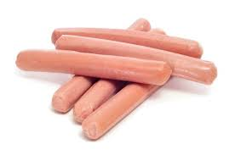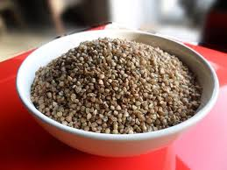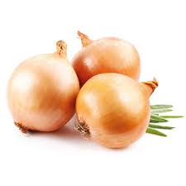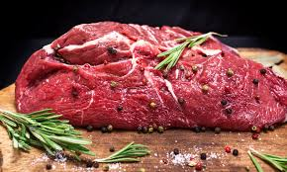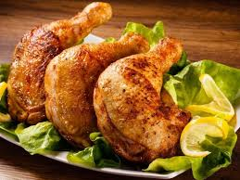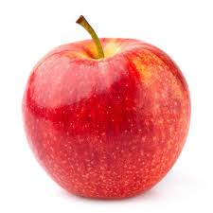

piletina

hajdinska kaša

luk

hrenovke

junetina

jabuka

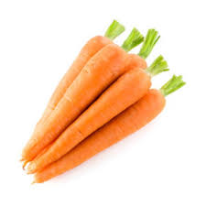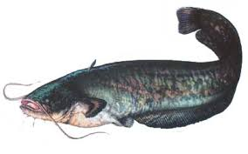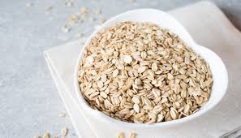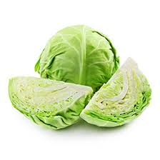

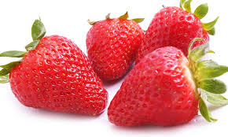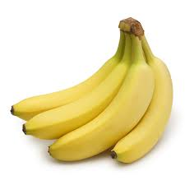

mrkve

som

zobene pahuljice

banane

kupus

jagode

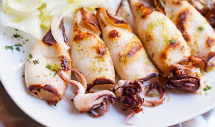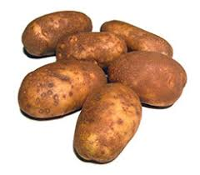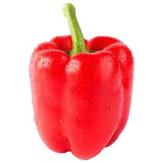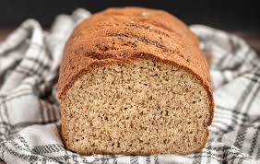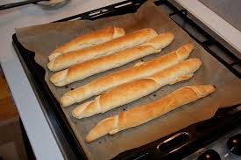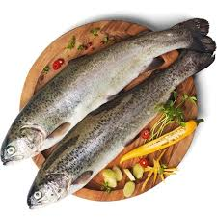

pastrva

slanac

kruh

paprika

krumpir

lignje