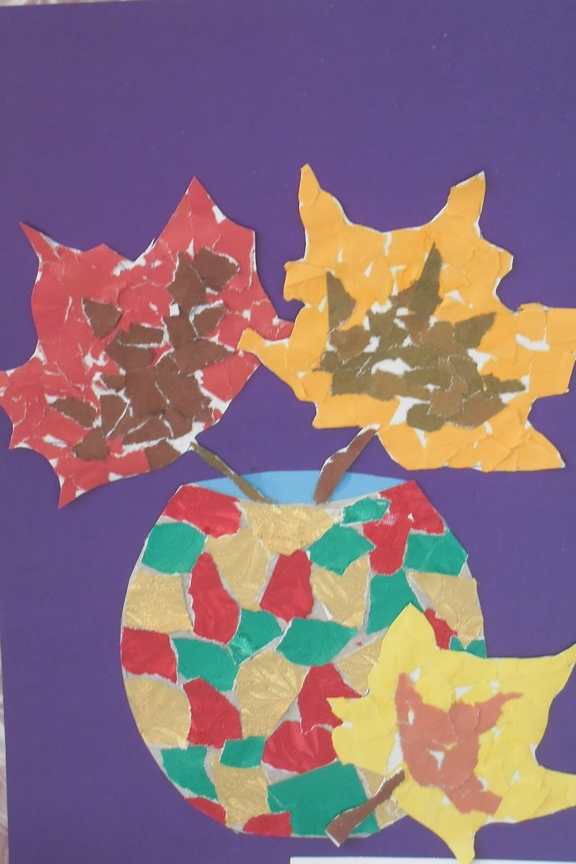

https://hr.womanuntamed.com/mosaic-paper/

