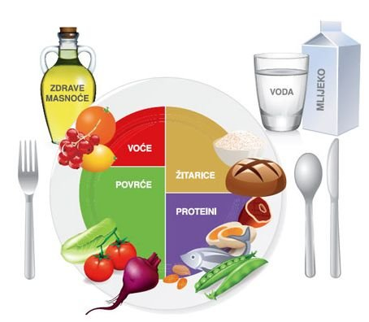
TANJUR PRAVILNE PREHRANE

