**DUGA**

[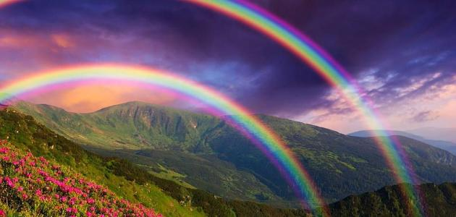](https://www.google.hr/url?sa=i&url=https://www.wishmama.hr/preporuke/znam-za-5/koliko-boja-ima-duga/&psig=AOvVaw1k3V8GfeceqrWiDpylKk_C&ust=1590618135094000&source=images&cd=vfe&ved=0CAIQjRxqFwoTCLjCmMDI0ukCFQAAAAAdAAAAABAD)

[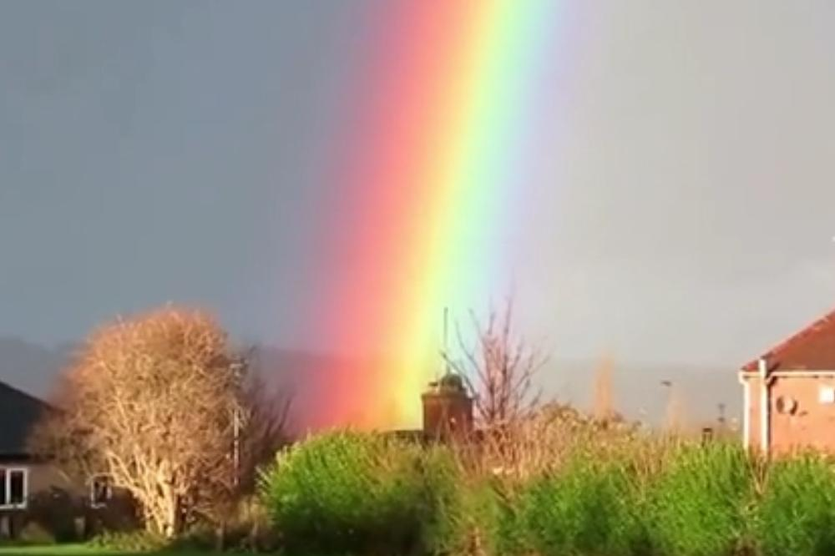](https://www.google.hr/url?sa=i&url=https://www.kurir.rs/zabava/zanimljivosti/2948663/video-najlepsa-duga-koju-ste-videli-boje-su-joj-lepse-nego-u-decijim-slikovnicama&psig=AOvVaw1k3V8GfeceqrWiDpylKk_C&ust=1590618135094000&source=images&cd=vfe&ved=0CAIQjRxqFwoTCLjCmMDI0ukCFQAAAAAdAAAAABAI)

[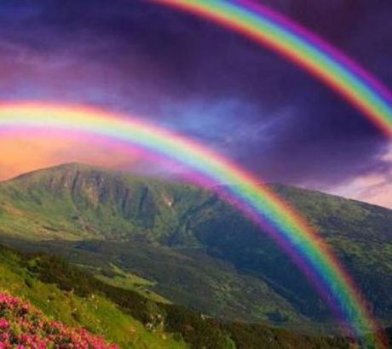](https://www.google.hr/url?sa=i&url=https://www.banjaluka.com/zanimljivosti/prekrasna-fotografija-covjek-nasao-kraj-duge-foto/&psig=AOvVaw1k3V8GfeceqrWiDpylKk_C&ust=1590618135094000&source=images&cd=vfe&ved=0CAIQjRxqFwoTCLjCmMDI0ukCFQAAAAAdAAAAABAT)

[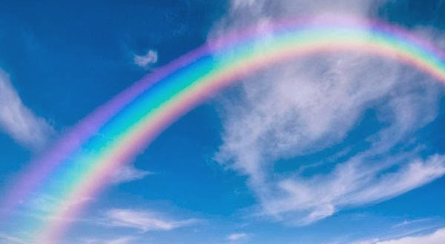](https://www.google.hr/url?sa=i&url=http://www.macvainfo.rs/page.php?secid%3D2%26pageid%3D2%26contid%3D1705%26%26model%3Dclanak%26ct%3Dduga-fenomen-i-tajna&psig=AOvVaw1k3V8GfeceqrWiDpylKk_C&ust=1590618135094000&source=images&cd=vfe&ved=0CAIQjRxqFwoTCLjCmMDI0ukCFQAAAAAdAAAAABAZ)