SUŠENJE RUBLJA

Uz pomoć sličica odgovori na sljedeća pitanja

1. Kakvo rublje stavljamo na sušenje?

[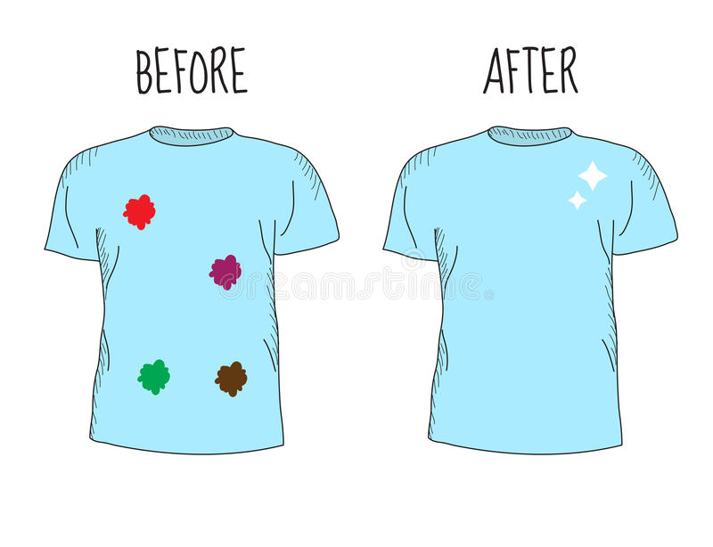](https://www.google.hr/url?sa=i&url=https://www.dreamstime.com/stock-illustration-dirty-clean-t-shirt-befor-cleaning-cleaning-t-shirt-different-types-stains-whitening-clothes-vector-illustration-image73379192&psig=AOvVaw2qwblod2LfSNYs-nrqIJNy&ust=1590044835387000&source=images&cd=vfe&ved=0CAIQjRxqFwoTCJCUgebwwekCFQAAAAAdAAAAABAO)

1. Kada ne stavljamo rublje sušiti vani?

[](https://www.google.hr/url?sa=i&url=https://www.vectorstock.com/royalty-free-vector/snow-cloud-vector-1767697&psig=AOvVaw2SE_VhIebqvSEEbwXscd9A&ust=1590045002214000&source=images&cd=vfe&ved=0CAIQjRxqFwoTCLjA87LxwekCFQAAAAAdAAAAABAJ)

[](https://www.google.hr/url?sa=i&url=https://www.123rf.com/stock-photo/cartoon_sun.html&psig=AOvVaw3CZ_MLpX-UlYZMd4rGORIX&ust=1590045030823000&source=images&cd=vfe&ved=0CAIQjRxqFwoTCKDK78HxwekCFQAAAAAdAAAAABAD)

[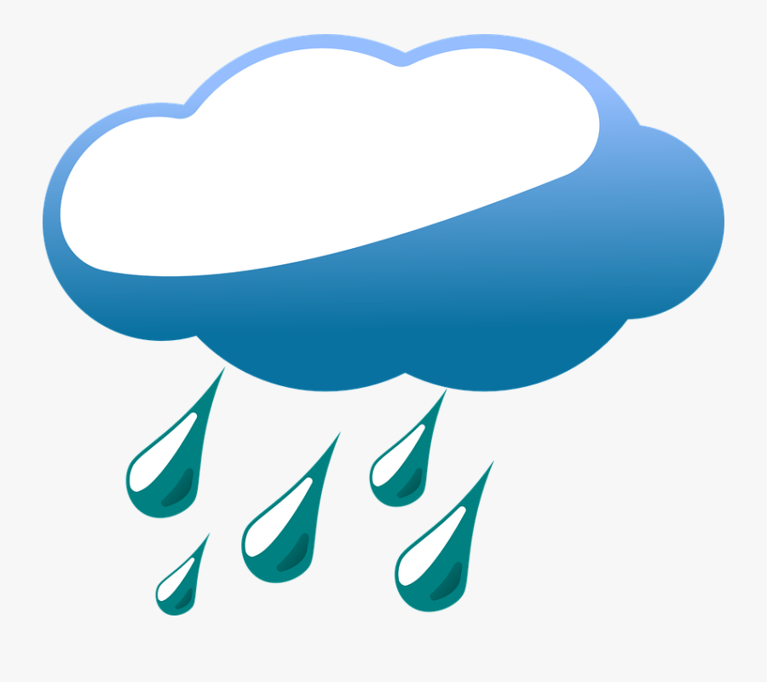](https://www.google.hr/url?sa=i&url=https://www.clipartkey.com/view/hJTRRJ_clouds-weather-rain-drops-rainy-day-clip-art/&psig=AOvVaw17YkNV_DXSUl_Owzt5GzL-&ust=1590044973222000&source=images&cd=vfe&ved=0CAIQjRxqFwoTCPCa3qTxwekCFQAAAAAdAAAAABAJ)

1. Čime kvačimo rublje za uže?

[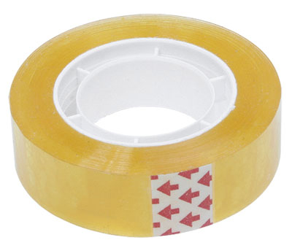](https://www.google.hr/url?sa=i&url=http://www.biro-media.hr/selotejp-1533-prozirni.aspx&psig=AOvVaw21qg3cf4w6Gq39AXRPPhdV&ust=1590045314776000&source=images&cd=vfe&ved=0CAIQjRxqFwoTCNCeisfywekCFQAAAAAdAAAAABAD)

[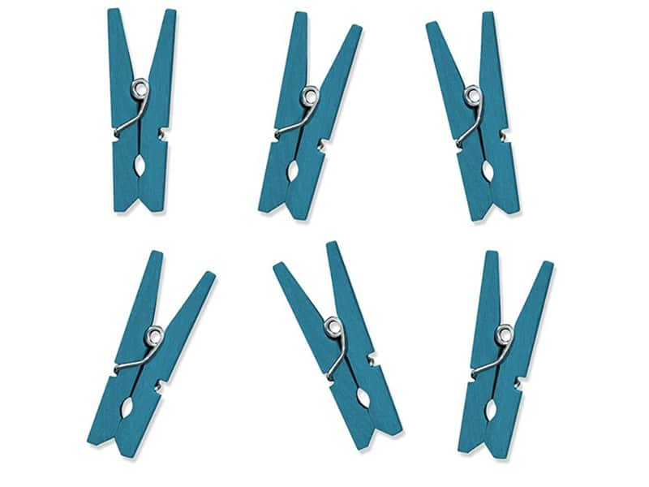](https://www.google.hr/url?sa=i&url=https://www.veseli-ducan.hr/trgovina/hobby-art/kvacice-drvene-plave-10-1/&psig=AOvVaw0lnF-DdP_F0JvepPh3WN9R&ust=1590045238727000&source=images&cd=vfe&ved=0CAIQjRxqFwoTCNDeq6fywekCFQAAAAAdAAAAABAb)

[](https://www.google.hr/url?sa=i&url=http://www.onlinerecepti.com.ba/nekoliko-nacina-na-koje-mozete-iskoristiti-spajalice-za-papir/&psig=AOvVaw3d0tl4v3DiGuGopNhRrR34&ust=1590045209962000&source=images&cd=vfe&ved=0CAIQjRxqFwoTCOjOupXywekCFQAAAAAdAAAAABAD)