MEDO I KLAVIR

Odgovori na pitanja uz pomoć slika. Odgovaraj cijelom rečenicom.

1. Koji instrument je ugledao medo u šumi ?

[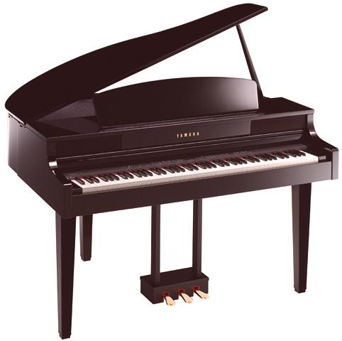](https://www.google.hr/url?sa=i&url=https://hr.radiopachone.org/klavir-i-glasovir-kako-se-razlikuju-i-sto-im-je-zajednicko-358&psig=AOvVaw1T_YaFd4hQJwEOeahu5SCu&ust=1589521703315000&source=images&cd=vfe&ved=0CAIQjRxqFwoTCKiC8YfUsukCFQAAAAAdAAAAABAQ)

[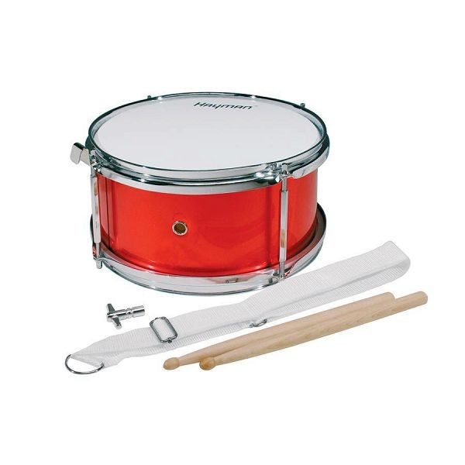](https://www.google.hr/url?sa=i&url=http://www.musicshopetida.hr/product.asp?product=hayman-djecji-bubanj-10&code=T%2DJSD%2D010%2DMR&psig=AOvVaw2jHuJ49TPmnqoKGQlOrADP&ust=1589521676959000&source=images&cd=vfe&ved=0CAIQjRxqFwoTCKDtwevTsukCFQAAAAAdAAAAABAP)

[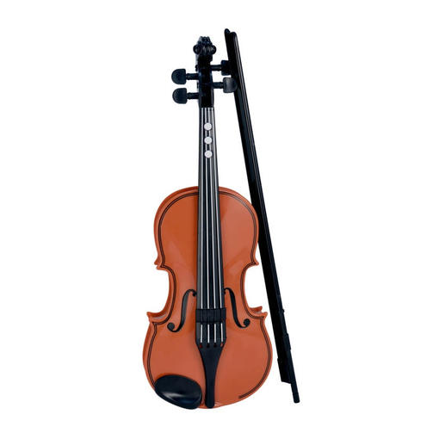](https://www.google.hr/url?sa=i&url=https://www.abrakadabra.com/hr-HR/Katalog-Igracke-Kreativne-igracke/violina/p/L00EIZC&psig=AOvVaw06hTcPWsu-hBoE6o0Nb5Rh&ust=1589521576757000&source=images&cd=vfe&ved=0CAIQjRxqFwoTCJj5wLzTsukCFQAAAAAdAAAAABAD)

1. Kako se medo osjećao kada je našao klavir?

[](https://www.google.hr/url?sa=i&url=https://webcomicms.net/clipart-9329826-emoticon-sad-gif&psig=AOvVaw26qV3qmO6Q4XgSgueFLi8b&ust=1589521978683000&source=images&cd=vfe&ved=0CAIQjRxqFwoTCLj-zf3UsukCFQAAAAAdAAAAABAJ)

[](https://www.google.hr/url?sa=i&url=https://www.pinterest.com/pin/414753446922459447/&psig=AOvVaw24pyeDRIBpsoIsvyykZyJg&ust=1589521941806000&source=images&cd=vfe&ved=0CAIQjRxqFwoTCNiai-rUsukCFQAAAAAdAAAAABAD)

[](https://www.google.hr/url?sa=i&url=https://www.walmart.com/ip/Smiley-Face-Circle-Badge-Back-Button/730108478&psig=AOvVaw2YECy52aGpzhRBVfH4VDTW&ust=1589521896449000&source=images&cd=vfe&ved=0CAIQjRxqFwoTCLDXy9TUsukCFQAAAAAdAAAAABAJ)

1. Tko je slušao medu kada je svirao?

[](https://www.google.hr/url?sa=i&url=https://www.pinterest.com/pin/160229699226947897/&psig=AOvVaw0WAjvHiF7zRj0QhA18E_ML&ust=1589522249252000&source=images&cd=vfe&ved=0CAIQjRxqFwoTCPiS1vzVsukCFQAAAAAdAAAAABAD)

[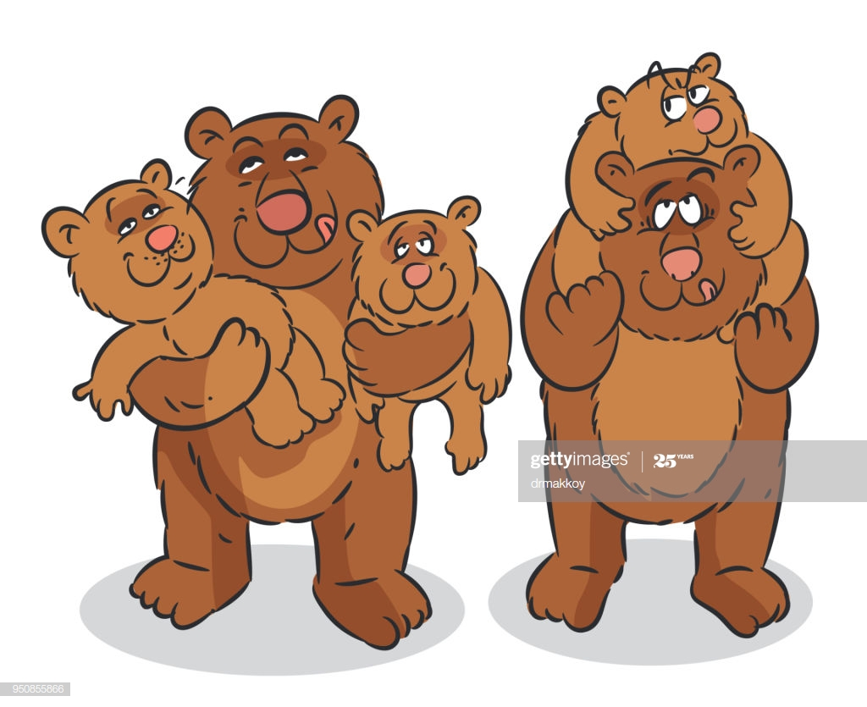](https://www.google.hr/url?sa=i&url=https://www.gettyimages.com/detail/illustration/bear-family-royalty-free-illustration/950855866&psig=AOvVaw3fgzxl8eO8kzwT2c7ZGDWB&ust=1589522118611000&source=images&cd=vfe&ved=0CAIQjRxqFwoTCIiin8LVsukCFQAAAAAdAAAAABAc)

[](https://www.google.hr/url?sa=i&url=http://clipart-library.com/grandmother-cliparts.html&psig=AOvVaw0DbmAzsVF8WfHmaFBRcNr4&ust=1589522089201000&source=images&cd=vfe&ved=0CAIQjRxqFwoTCNDKlrDVsukCFQAAAAAdAAAAABAD)

1. Tko je medi rekao kako se zove instrument koji svira?

[](https://www.google.hr/url?sa=i&url=https://www.dreamstime.com/royalty-free-stock-photos-cartoon-happy-girl-boy-image14334438&psig=AOvVaw0DLFxqShnTEqUIjrgRzcSp&ust=1589522370151000&source=images&cd=vfe&ved=0CAIQjRxqFwoTCKCE67bWsukCFQAAAAAdAAAAABAJ)

[](https://www.google.hr/url?sa=i&url=https://www.etsy.com/listing/550245394/custom-birds-cartoon-birds-blue-birds&psig=AOvVaw2LyGa0bu_Ld6V_QHTANp1D&ust=1589522348313000&source=images&cd=vfe&ved=0CAIQjRxqFwoTCPCv2avWsukCFQAAAAAdAAAAABAD)

[](https://www.google.hr/url?sa=i&url=https://nl.freepik.com/premium-vector/cartoon-grappige-kat-geisoleerd_5117358.htm&psig=AOvVaw12BmGyHMsN8o3uOxcL0B26&ust=1589522403138000&source=images&cd=vfe&ved=0CAIQjRxqFwoTCJD2-MbWsukCFQAAAAAdAAAAABAN)

1. Gdje je medo imao koncert?

[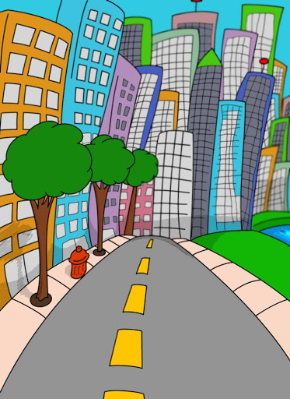](https://www.google.hr/url?sa=i&url=http://www.aljanh.net/cartoon-town-wallpapers/249128361.html&psig=AOvVaw3hmHhQ3M2-BS2C9_D9u-_U&ust=1589522655016000&source=images&cd=vfe&ved=0CAIQjRxqFwoTCLCM7cjXsukCFQAAAAAdAAAAABAJ)

[](https://www.google.hr/url?sa=i&url=https://de.cleanpng.com/png-2ayasg/&psig=AOvVaw1rIxgxLThr4gDJPqx3n5BC&ust=1589522630142000&source=images&cd=vfe&ved=0CAIQjRxqFwoTCNifwLPXsukCFQAAAAAdAAAAABAD)

1. Tko je medi nedostajao?

[](https://www.google.hr/url?sa=i&url=https://www.gettyimages.com/detail/illustration/bear-family-royalty-free-illustration/950855866&psig=AOvVaw3fgzxl8eO8kzwT2c7ZGDWB&ust=1589522118611000&source=images&cd=vfe&ved=0CAIQjRxqFwoTCIiin8LVsukCFQAAAAAdAAAAABAc)

[](https://www.google.hr/url?sa=i&url=https://www.istockphoto.com/vector/tropical-fish-cartoon-gm585497830-100409901&psig=AOvVaw1oZ4l__eUR7UcPaPo8D_bX&ust=1589522795938000&source=images&cd=vfe&ved=0CAIQjRxqFwoTCICh3oTYsukCFQAAAAAdAAAAABAE)

1. Kamo se medo vratio?

[](https://www.google.hr/url?sa=i&url=https://www.vectorstock.com/royalty-free-vector/forest-scene-with-trail-in-the-woods-vector-8071450&psig=AOvVaw3GfOzGjiD9mLatpFwRiIeW&ust=1589522886209000&source=images&cd=vfe&ved=0CAIQjRxqFwoTCLi3ja3YsukCFQAAAAAdAAAAABAJ)

[](https://www.google.hr/url?sa=i&url=https://www.youtube.com/watch?v=FKirSYCvBZ4&psig=AOvVaw1vR-CobROtiW9YG_JFmSoC&ust=1589522964154000&source=images&cd=vfe&ved=0CAIQjRxqFwoTCKC-yNHYsukCFQAAAAAdAAAAABAD)

1. Kako se medo osjećao kada je ponovo bio sa prijateljima?

[](https://www.google.hr/url?sa=i&url=https://www.thepeacefuldragon.com/can-martial-arts-help-with-anger-management-and-aggression-issues/angry-face/&psig=AOvVaw3sWRHYClPC_gvCLI4yMxja&ust=1589523104968000&source=images&cd=vfe&ved=0CAIQjRxqFwoTCMjm_ZbZsukCFQAAAAAdAAAAABAJ)

[](https://www.google.hr/url?sa=i&url=https://www.walmart.com/ip/Smiley-Face-Circle-Badge-Back-Button/730108478&psig=AOvVaw2YECy52aGpzhRBVfH4VDTW&ust=1589521896449000&source=images&cd=vfe&ved=0CAIQjRxqFwoTCLDXy9TUsukCFQAAAAAdAAAAABAJ)

[](https://www.google.hr/url?sa=i&url=https://webcomicms.net/clipart-9329826-emoticon-sad-gif&psig=AOvVaw26qV3qmO6Q4XgSgueFLi8b&ust=1589521978683000&source=images&cd=vfe&ved=0CAIQjRxqFwoTCLj-zf3UsukCFQAAAAAdAAAAABAJ)