Moja mama

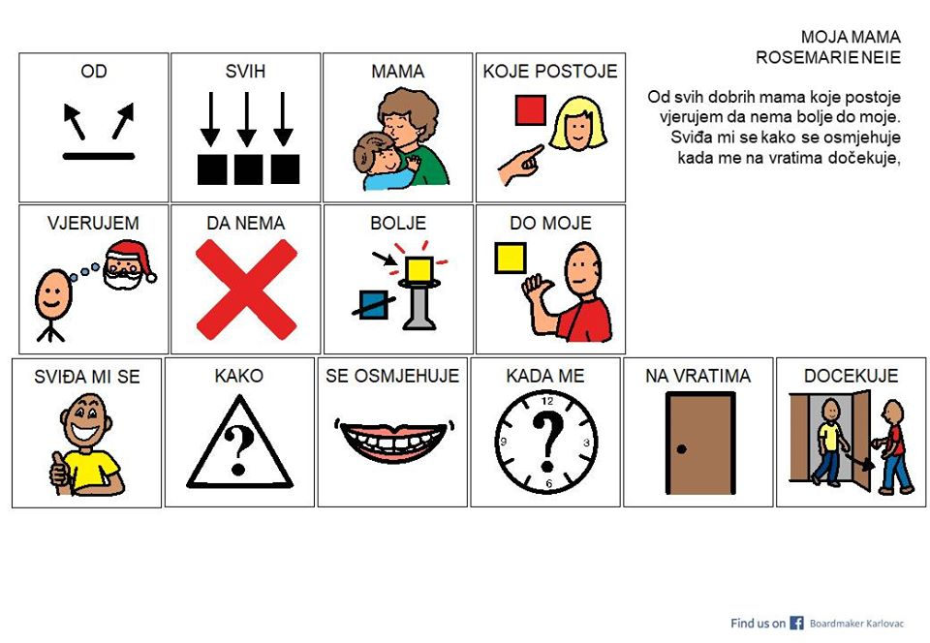

Moja je

VESELA

NJEŽNA

DOBRA

Lice joj je

[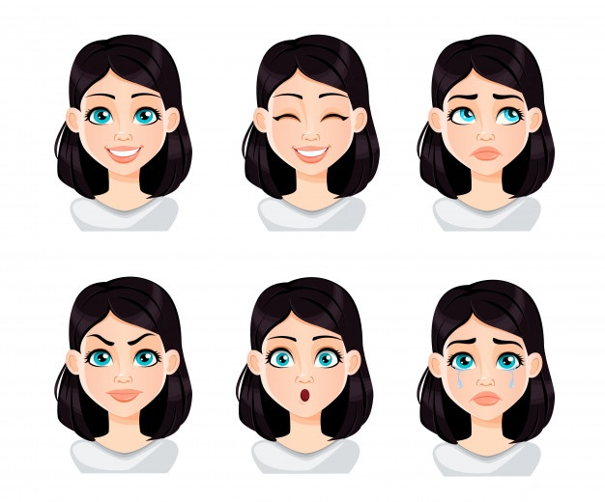](https://www.google.hr/url?sa=i&url=https://www.freepik.com/premium-vector/face-expressions-woman-with-dark-hair_5783957.htm&psig=AOvVaw0iZ6-ojXLeQdyLS80WkZnl&ust=1588967920674000&source=images&cd=vfe&ved=0CAIQjRxqFwoTCPiqr_nEoukCFQAAAAAdAAAAABAR)

[](https://www.google.hr/url?sa=i&url=https://www.freepik.com/premium-vector/face-expressions-woman-with-dark-hair_5783957.htm&psig=AOvVaw0iZ6-ojXLeQdyLS80WkZnl&ust=1588967920674000&source=images&cd=vfe&ved=0CAIQjRxqFwoTCPiqr_nEoukCFQAAAAAdAAAAABAR)

[](https://www.google.hr/url?sa=i&url=https://www.freepik.com/premium-vector/face-expressions-woman-with-dark-hair_5783957.htm&psig=AOvVaw0iZ6-ojXLeQdyLS80WkZnl&ust=1588967920674000&source=images&cd=vfe&ved=0CAIQjRxqFwoTCPiqr_nEoukCFQAAAAAdAAAAABAR)

[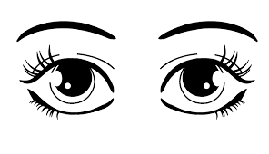](https://www.google.hr/url?sa=i&url=http://clipartbarn.com/eyeballs-clipart_23719/&psig=AOvVaw2joJjgBD5KQ7Ht1ZgXgQlC&ust=1588968290451000&source=images&cd=vfe&ved=0CAIQjRxqFwoTCJD92rHGoukCFQAAAAAdAAAAABAO)

su joj boje.

[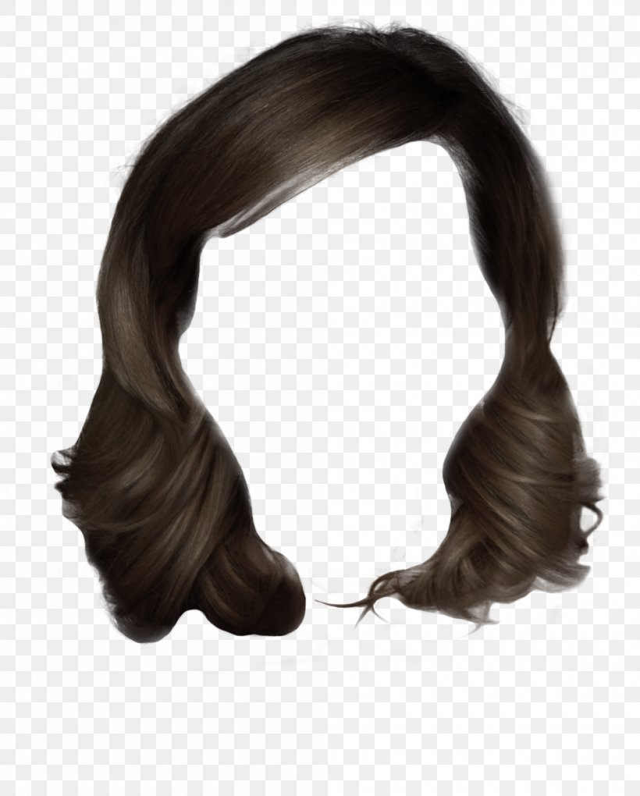](https://www.google.hr/url?sa=i&url=https://favpng.com/png_view/layered-hair-lace-wig-hair-cartoon-png/T5DzwH53&psig=AOvVaw1KBTfFyiz3dOaUqQfW7HxI&ust=1588968549041000&source=images&cd=vfe&ved=0CAIQjRxqFwoTCOjbp63HoukCFQAAAAAdAAAAABAJ)

[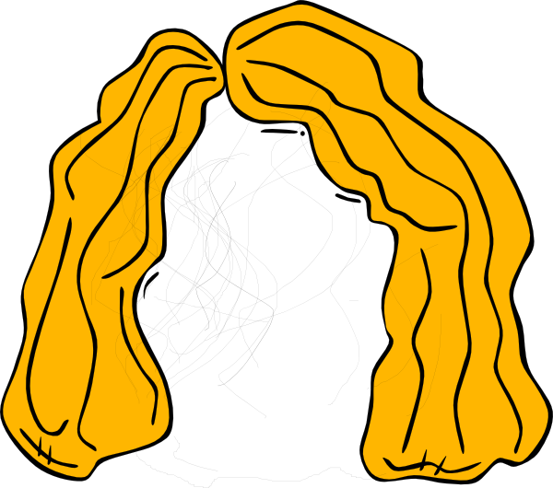](https://www.google.hr/url?sa=i&url=https://webstockreview.net/explore/hair-clipart-animated/&psig=AOvVaw1KBTfFyiz3dOaUqQfW7HxI&ust=1588968549041000&source=images&cd=vfe&ved=0CAIQjRxqFwoTCOjbp63HoukCFQAAAAAdAAAAABAD)

Ona ima

[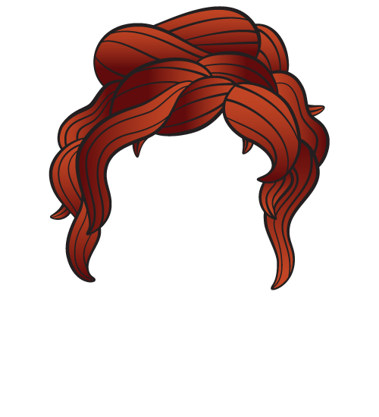](https://www.google.hr/url?sa=i&url=https://pngimage.net/cartoon-hair-png-1/&psig=AOvVaw1KBTfFyiz3dOaUqQfW7HxI&ust=1588968549041000&source=images&cd=vfe&ved=0CAIQjRxqFwoTCOjbp63HoukCFQAAAAAdAAAAABAP)

kosu.

