**[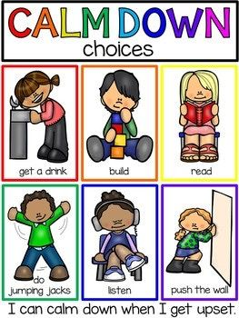](https://www.teacherspayteachers.com/Product/Calm-Down-Techniques-Books-Posters-and-Supports-2734315)**

**[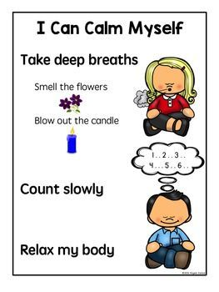](https://www.teacherspayteachers.com/Product/Calm-Down-Strategies-and-Self-Regulation-Posters-2502997)**

**[](https://www.teacherspayteachers.com/Product/Calm-Down-Strategies-and-Self-Regulation-Posters-2502997)**

KAKO SE MOGU SMIRITI

KADA SAM LJUT

Pritiskati zid

Slušati glazbu

Skakati

Čitati slikovnicu

Igrati se kockama

Piti vodu

Brojiti do 10

Duboko disati