ČAROBNE RIJEČI

HVALA

IZVOLI

[](https://www.google.hr/url?sa=i&url=https://www.fotosearch.com/CSP025/k0252261/&psig=AOvVaw1yQu1m_m97GMNZoMqDmwzV&ust=1586969511207000&source=images&cd=vfe&ved=0CAIQjRxqFwoTCJj46Kiw6OgCFQAAAAAdAAAAABAO)

OPROSTI

[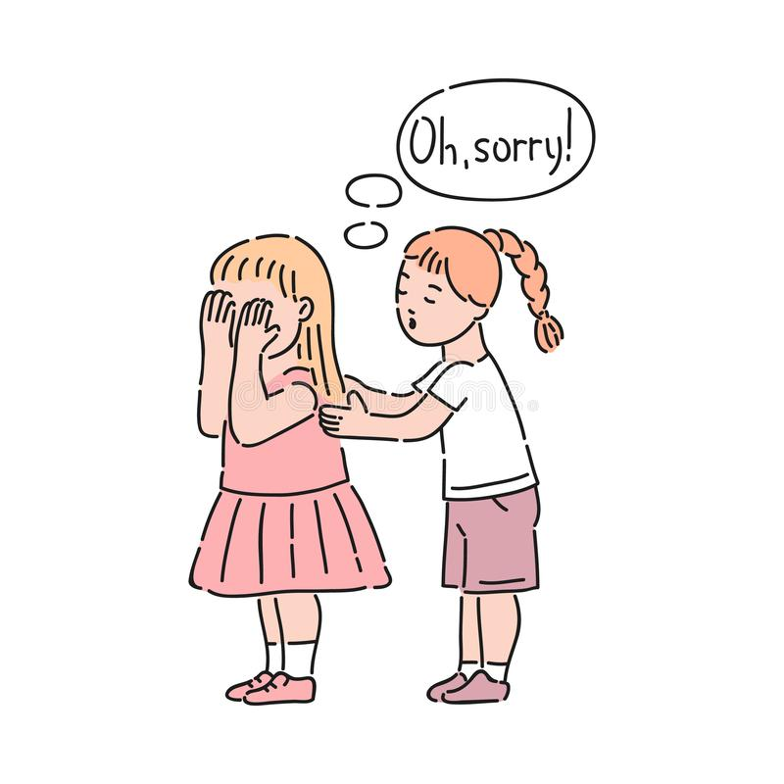](https://www.google.hr/url?sa=i&url=https://www.dreamstime.com/vector-well-behaved-girl-calming-down-crying-saying-sorry-good-manners-politeness-female-kid-decenity-urbanity-children-image145242787&psig=AOvVaw2WbGIRF9YYEbSe9SntzMdP&ust=1586969716811000&source=images&cd=vfe&ved=0CAIQjRxqFwoTCPjMrpCx6OgCFQAAAAAdAAAAABAY)

MOLIM

[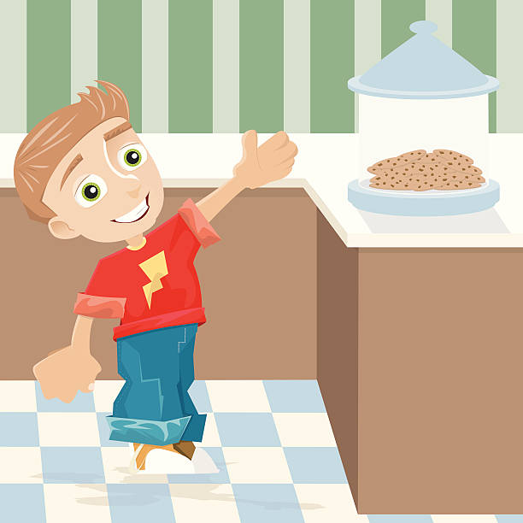](https://www.google.hr/url?sa=i&url=https://www.clipart.email/clipart/cookies-jar-clipart-34290.html&psig=AOvVaw3JxxL1LC-A5VYgrzizN9U3&ust=1586970022074000&source=images&cd=vfe&ved=0CAIQjRxqFwoTCJCt96Gy6OgCFQAAAAAdAAAAABAK)