[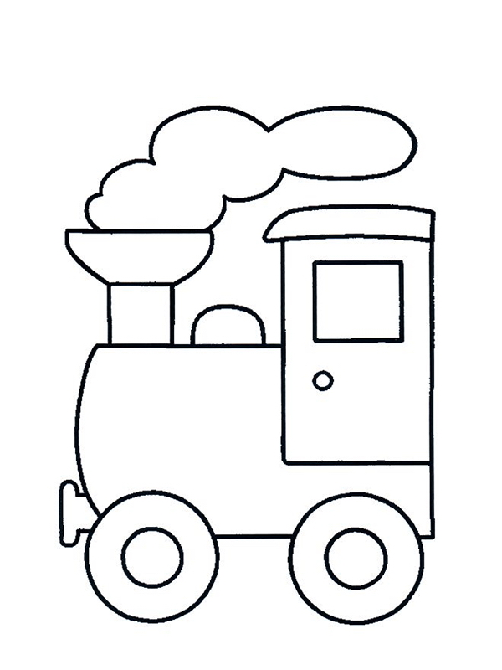](https://www.google.hr/url?sa=i&url=https://www.bojanke.com/vozovi.htm&psig=AOvVaw2qLzjF8Zbi_-akbIkLZ7DU&ust=1586888157461000&source=images&cd=vfe&ved=0CAIQjRxqFwoTCPCMrpyB5ugCFQAAAAAdAAAAABAD)

[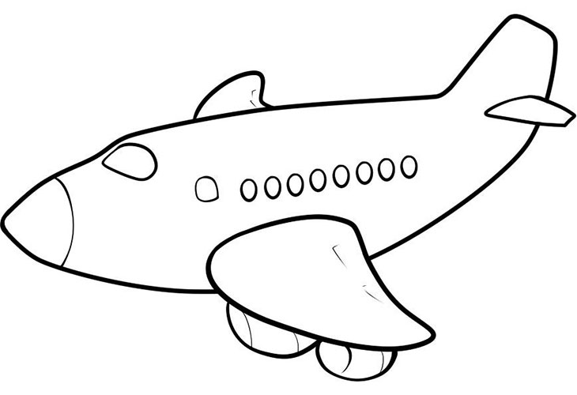](https://www.google.hr/url?sa=i&url=https://opusteno.rs/slike/2014/01/crtanje-aviona-21345/kako-nacrtati-avion-44.html&psig=AOvVaw01Vd3t-cSTW59gjqiH9Q1h&ust=1586888278157000&source=images&cd=vfe&ved=0CAIQjRxqFwoTCNCwutaB5ugCFQAAAAAdAAAAABAD)

[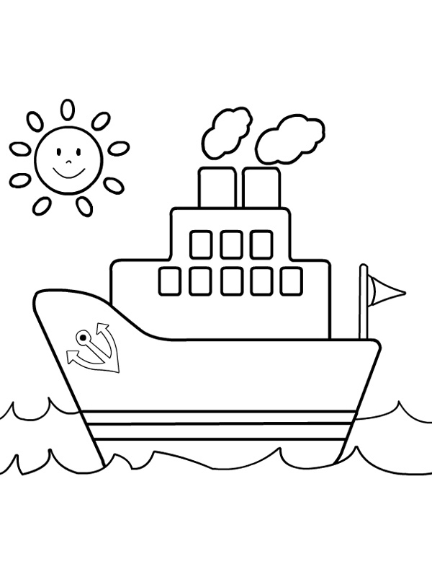](https://www.google.hr/url?sa=i&url=https://www.bojanke.com/brodovi.htm&psig=AOvVaw1Rln6ozrk7Y45yixltlUNQ&ust=1586888330913000&source=images&cd=vfe&ved=0CAIQjRxqFwoTCIian_KB5ugCFQAAAAAdAAAAABAD)