[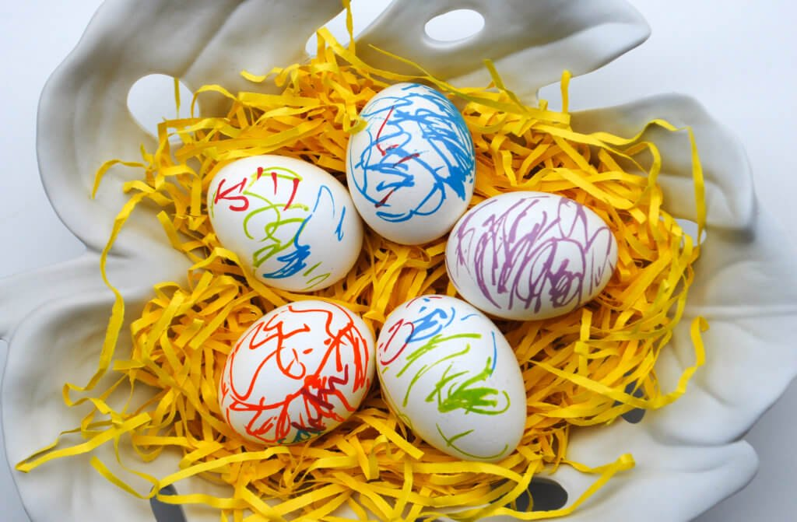](https://www.google.hr/url?sa=i&url=https://www.merrimentdesign.com/paint-pen-easter-eggs-easy-kids-craft.php&psig=AOvVaw0IT3_pIINqm4Mbio2uGLFE&ust=1586288382277000&source=images&cd=vfe&ved=0CAIQjRxqFwoTCKimwvPG1OgCFQAAAAAdAAAAABAJ)

