[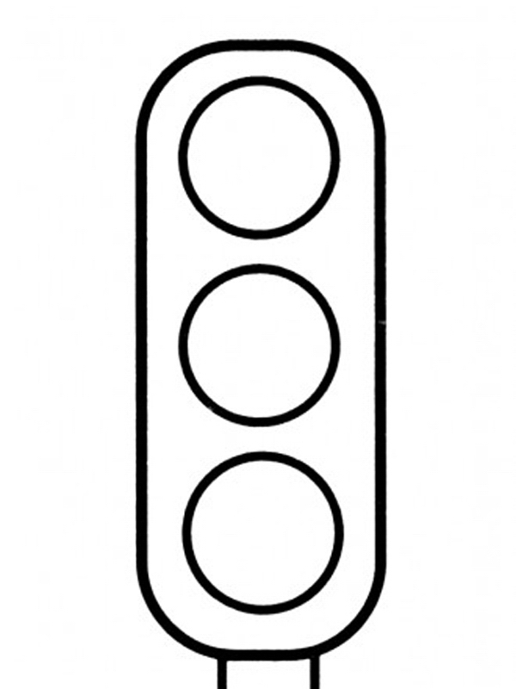](https://www.google.hr/url?sa=i&url=http://www.bojanke.com/saobracajni_znaci.htm&psig=AOvVaw0YB0ZwDmP2POA-TpPwmOWt&ust=1586185542219000&source=images&cd=vfe&ved=0CAIQjRxqFwoTCLjyi-bH0egCFQAAAAAdAAAAABAD)

**SEMAFOR**

[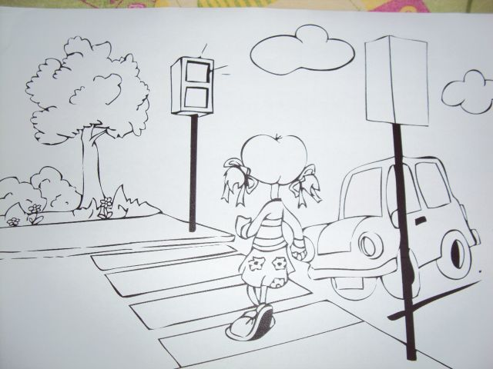](https://www.google.hr/url?sa=i&url=https://www.sigurnacesta-ppm.hr/preventiva-mladih/predskolski-odgoj/viroviticko-podravska/djeca-predskolske-dobi-u-prometu/&psig=AOvVaw3F3yqrsZ_UppPdC-Qlb_Z4&ust=1586185599213000&source=images&cd=vfe&ved=0CAIQjRxqFwoTCKjx_5jI0egCFQAAAAAdAAAAABAF)

**PJEŠAČKI PRIJELAZ**

**[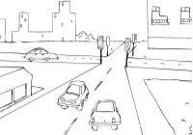](https://www.google.hr/url?sa=i&url=http://ucilica.skole.hr/igra-zabavni&psig=AOvVaw0DzZovdQip7Ik8fM_Ewd9W&ust=1586185836058000&source=images&cd=vfe&ved=0CAIQjRxqFwoTCPjOvfnI0egCFQAAAAAdAAAAABAE)**

STAZA ZA PJEŠAKE