PRIMJERI PISANICA

 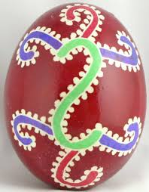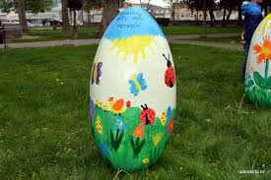 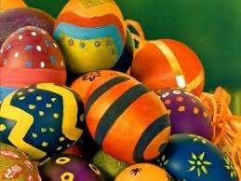 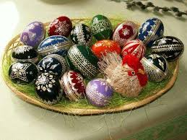 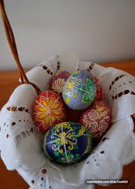 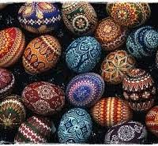 [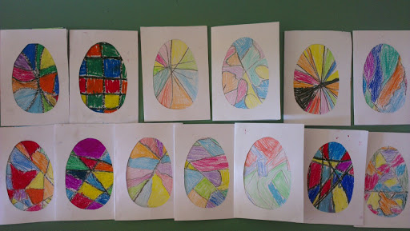](https://www.google.hr/url?sa=i&url=http://www.os-ivanska.skole.hr/print/?prt_name%3Dnews%26prt_id%3D164&psig=AOvVaw0iwuoK5G8_bAt2uG7doH4C&ust=1586243120733000&source=images&cd=vfe&ved=0CAIQjRxqFwoTCKjr6Lme0-gCFQAAAAAdAAAAABAL)