**TROKUT**

**[](https://www.google.hr/url?sa=i&url=https%3A%2F%2Fwww.e-sfera.hr%2Fdodatni-digitalni-sadrzaji%2Fdd0db0a9-dacf-4713-81b6-062ba47ca89c%2F&psig=AOvVaw2ZhvZ5Zp4M8jfGxlASJjk-&ust=1585816760538000&source=images&cd=vfe&ved=0CAIQjRxqFwoTCNjln_3pxugCFQAAAAAdAAAAABAD)**

**[](https://www.google.hr/url?sa=i&url=http%3A%2F%2Fdocplayer.rs%2F161642122-1-dio-2.html&psig=AOvVaw1XG35rOyKECPOlMGJ-lC9G&ust=1585817433809000&source=images&cd=vfe&ved=0CAIQjRxqFwoTCMidvMDsxugCFQAAAAAdAAAAABAQ)**

**KRUG**

|  |
| --- |
|  |

**KOCKA**

**[](https://www.google.hr/url?sa=i&url=https://repozitorij.etfos.hr/islandora/object/etfos%3A1594/datastream/PDF/view&psig=AOvVaw3yLY4fR-XOLu4TWi_sv7Vq&ust=1585773246322000&source=images&cd=vfe&ved=0CAIQjRxqFwoTCJChjvHHxegCFQAAAAAdAAAAABAE)**[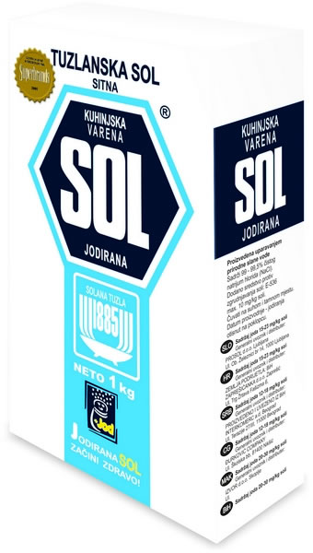](https://www.google.hr/url?sa=i&url=https://www.jatrgovac.com/tuzlanska-sol-stogodisnja-tradicija-prisutnosti-na-trzistu/&psig=AOvVaw3KznsA56Aw7EQG8ElQv6cL&ust=1585773334224000&source=images&cd=vfe&ved=0CAIQjRxqFwoTCPiR65rIxegCFQAAAAAdAAAAABAO)

**[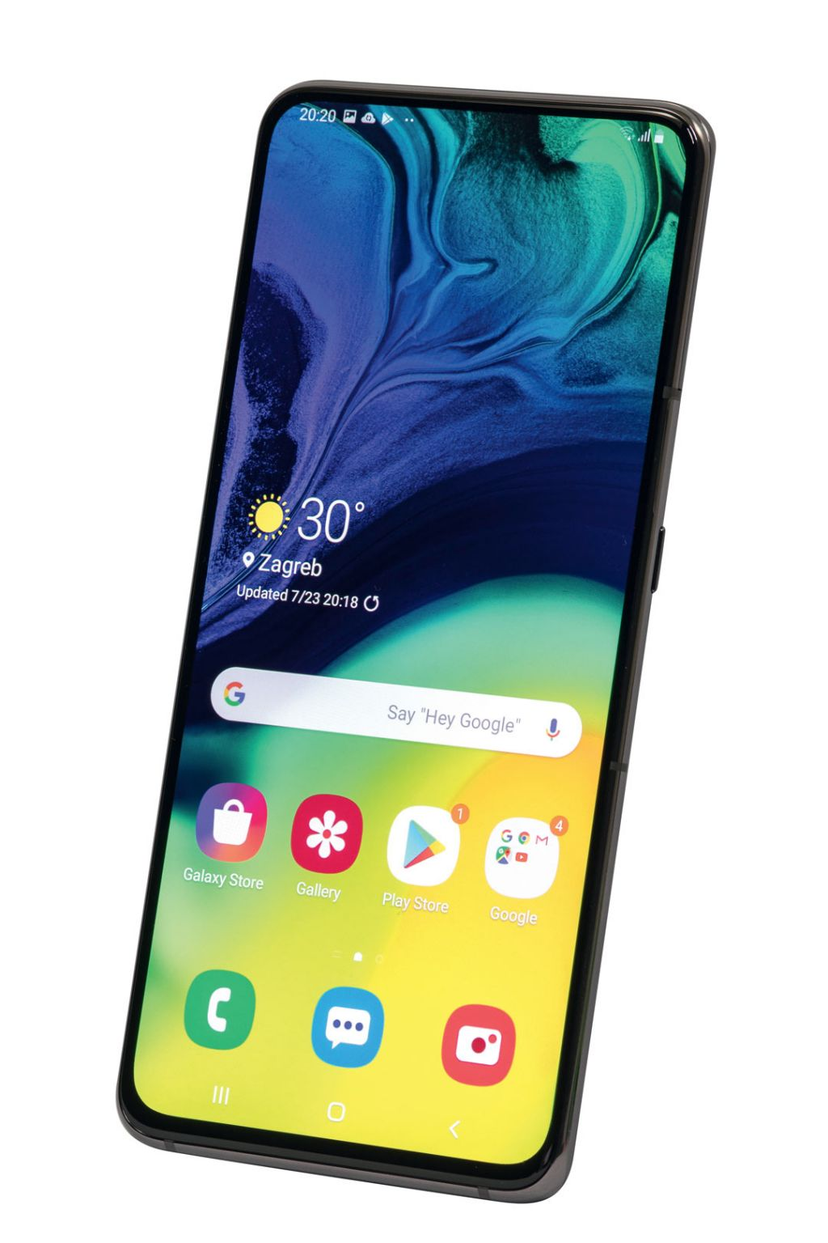](https://www.google.hr/url?sa=i&url=https://www.vidilab.com/hardver/mobil/pametni-telefon/4494-samsung-galaxy-a80&psig=AOvVaw3bZkuOMQrSMfGlvydcxUEk&ust=1585769098158000&source=images&cd=vfe&ved=0CAIQjRxqFwoTCKCbgYi3xegCFQAAAAAdAAAAABAg)MOBITEL**