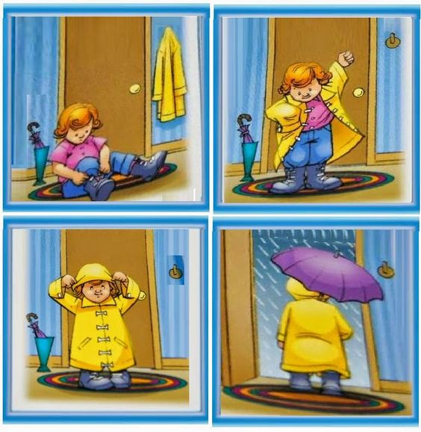
Slika preuzeta sa sljedeće stranice: https://www.pinterest.com/ivanakljaic1/prica-po-nizu-slika/
Slika 1.________________________________________________________________________
________________________________________________________________________

Slika 2.________________________________________________________________________
________________________________________________________________________

Slika 3.________________________________________________________________________
________________________________________________________________________

Slika 4.________________________________________________________________________
________________________________________________________________________

