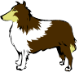 voli [](https://www.google.hr/url?sa=i&url=https://paintingvalley.com/dog-bone-drawing&psig=AOvVaw2-pAzNuRbdn1BoiAp24ha1&ust=1585326818434000&source=images&cd=vfe&ved=0CAIQjRxqFwoTCIjSx-XIuOgCFQAAAAAdAAAAABAD) .

Pas voli kost.

[](https://www.google.hr/url?sa=i&url=https://www.pinterest.com/pin/332844228703770847/&psig=AOvVaw0FZoKPjWv0LtLDJkB8A6Bn&ust=1585327067161000&source=images&cd=vfe&ved=0CAIQjRxqFwoTCIiOz9nJuOgCFQAAAAAdAAAAABAD) lovi [](https://www.google.hr/url?sa=i&url=https://www.kindpng.com/imgv/bimiJJ_clipart-of-neutral-2-ear-and-2-mouse/&psig=AOvVaw1v7Az4J9ZpSZ9SC33m_Mcd&ust=1585327151321000&source=images&cd=vfe&ved=0CAIQjRxqFwoTCNCzk4LKuOgCFQAAAAAdAAAAABAd).

Mačka lovi miša.

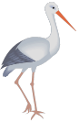 gleda 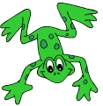.

Roda gleda žabu.