MD – UTORAK 24.3.2020.
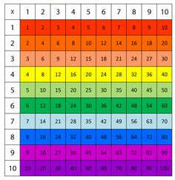
POMNOŽI:
10 X 2 = 10 X 5 =
7 X 3 = 9 X 4 =
8 X 3 = 8 X 8 =
4 X 5 = 7 X 8 =
8 X 5 = 6 X 7 =
2 X 9 = 10 X 0 =

